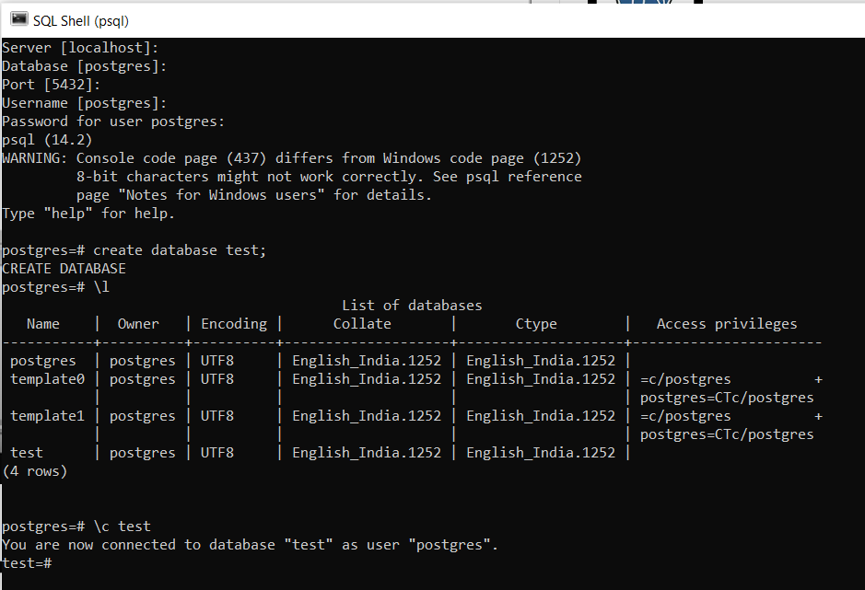

Using sql shell pressing enter till we reach password and type it.

Using commands in pictures we continue.

\l used to list all databases present.

\c test to select test database out of all available databases.



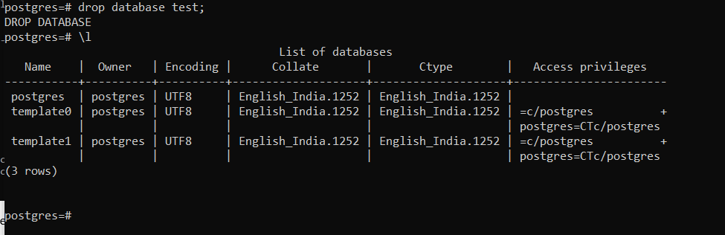

drop to remove table.

\q to disconnect all databases.

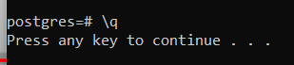

Using pgadmin4 also it can be done right click on databases to add / drop new databases.

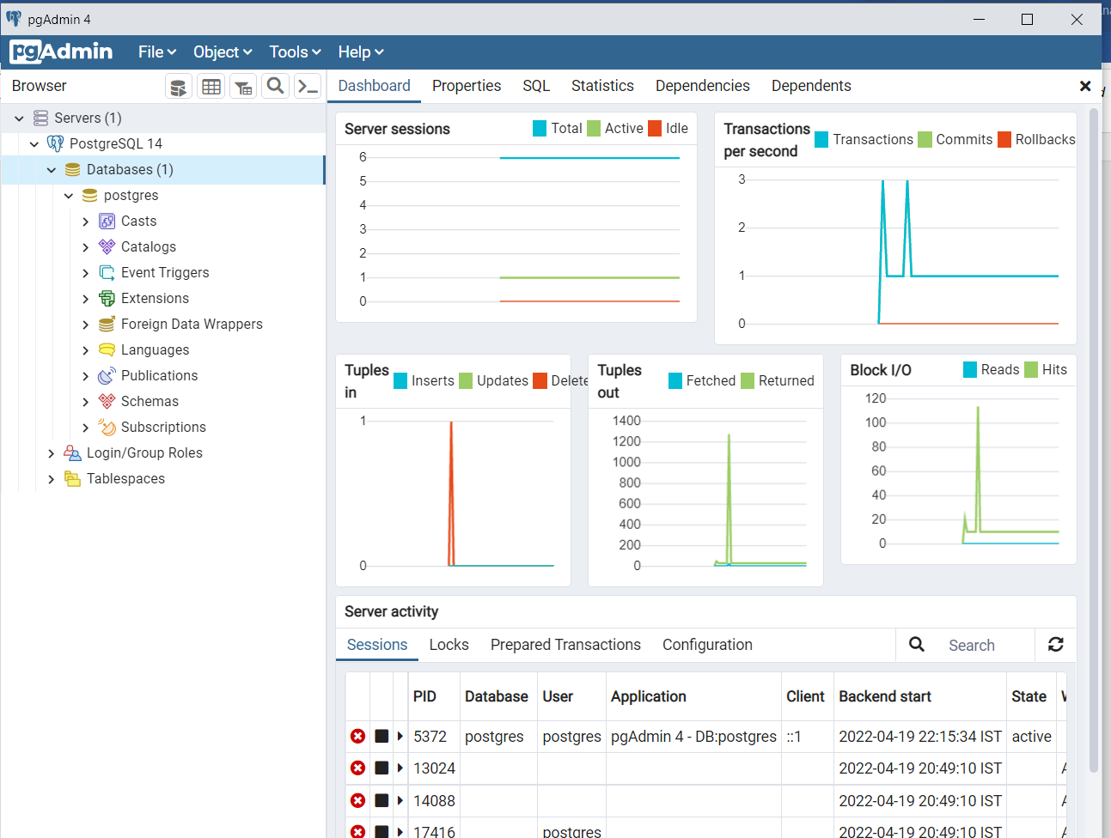

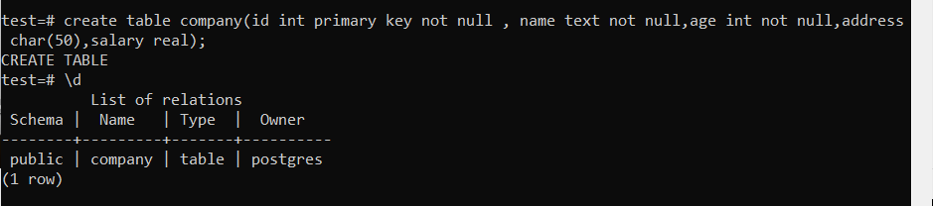

\d to describe table.

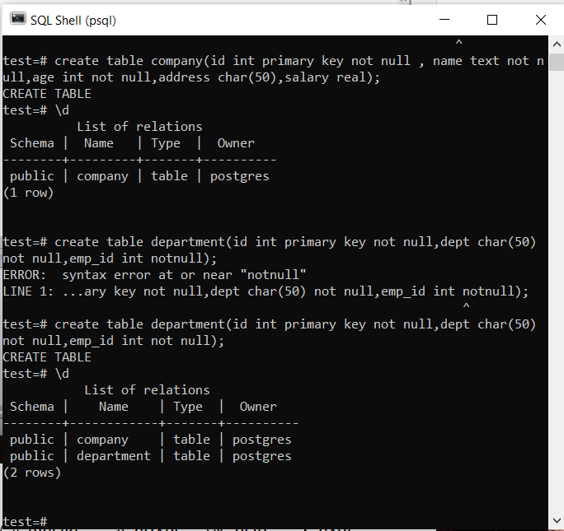

After doing all above steps table test will be available in pgadmin4. If not restart.

Belo how to reach to tables in pgadmin4.

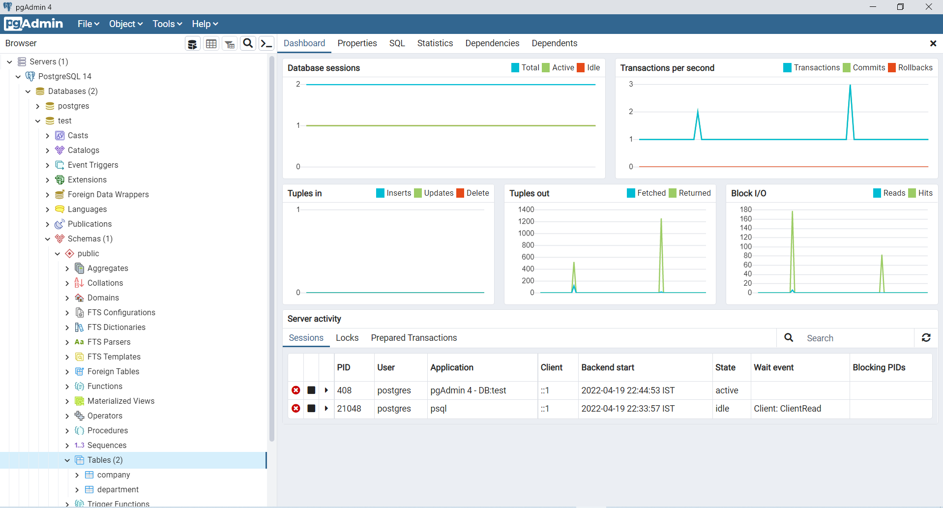

Right clicking on Tables(2) icon to create new table. Filling in general ,column where to fill name of column etc.

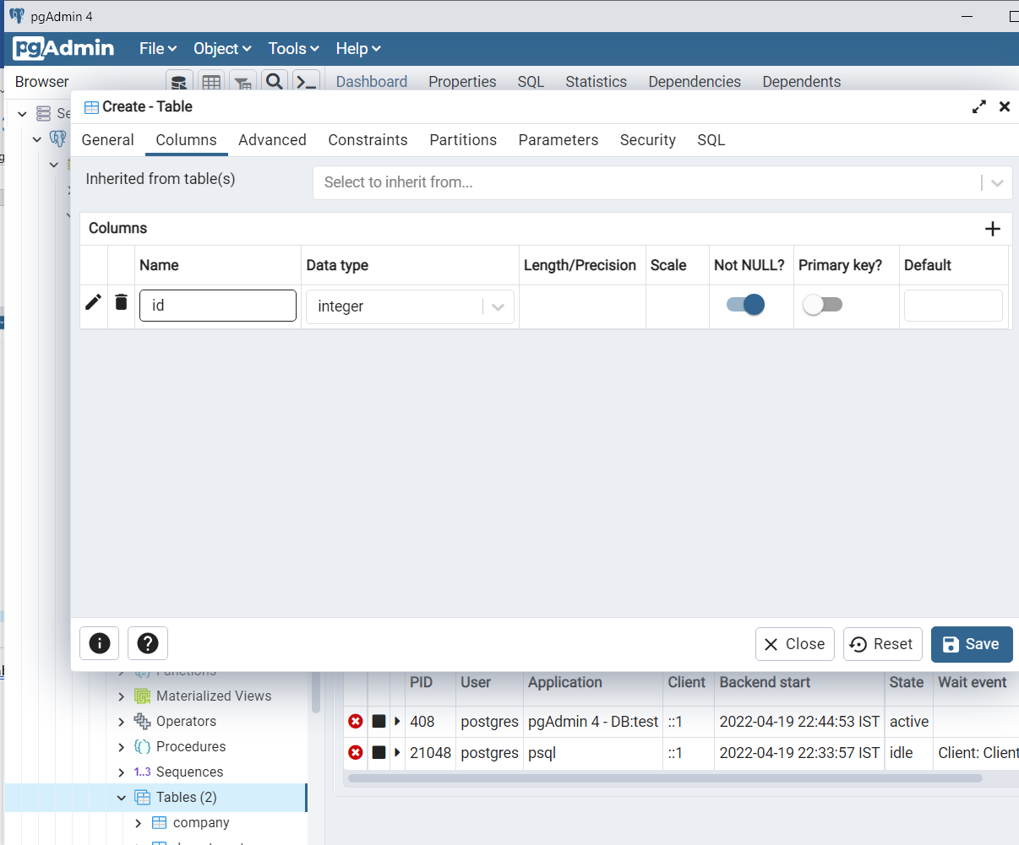

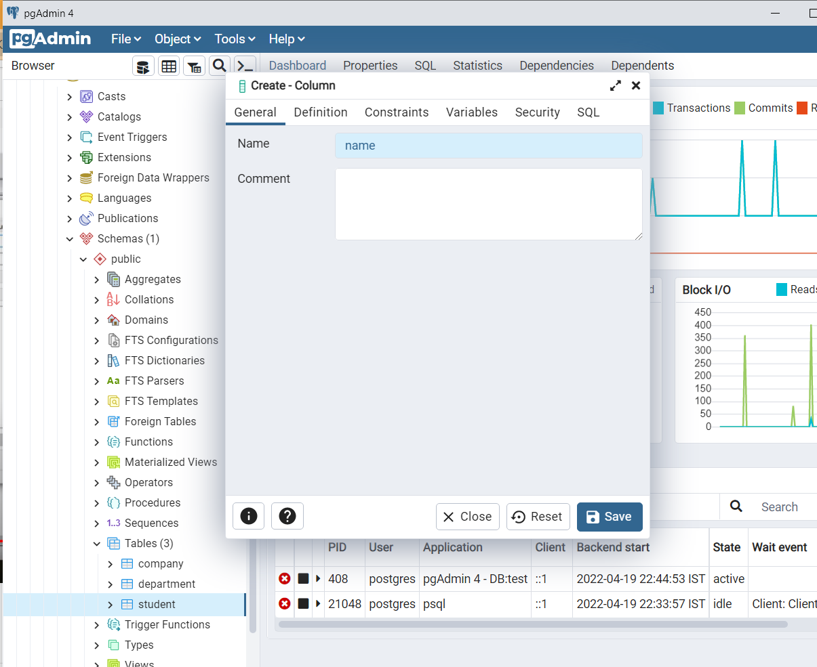

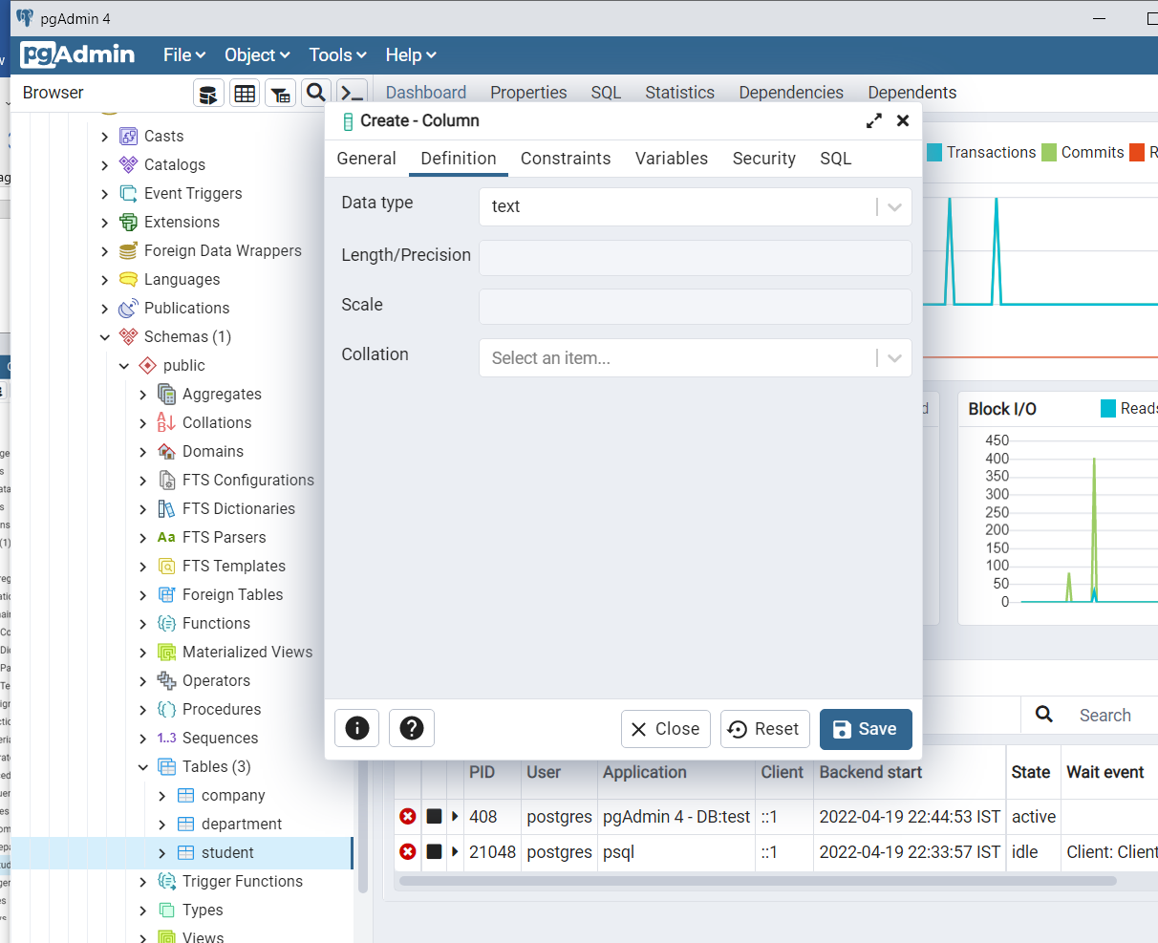

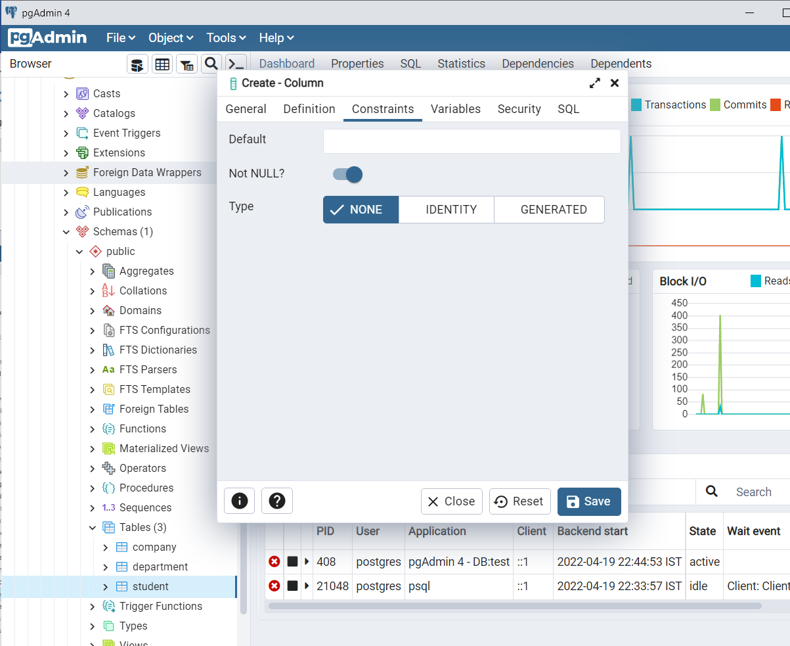

Id as primary key.

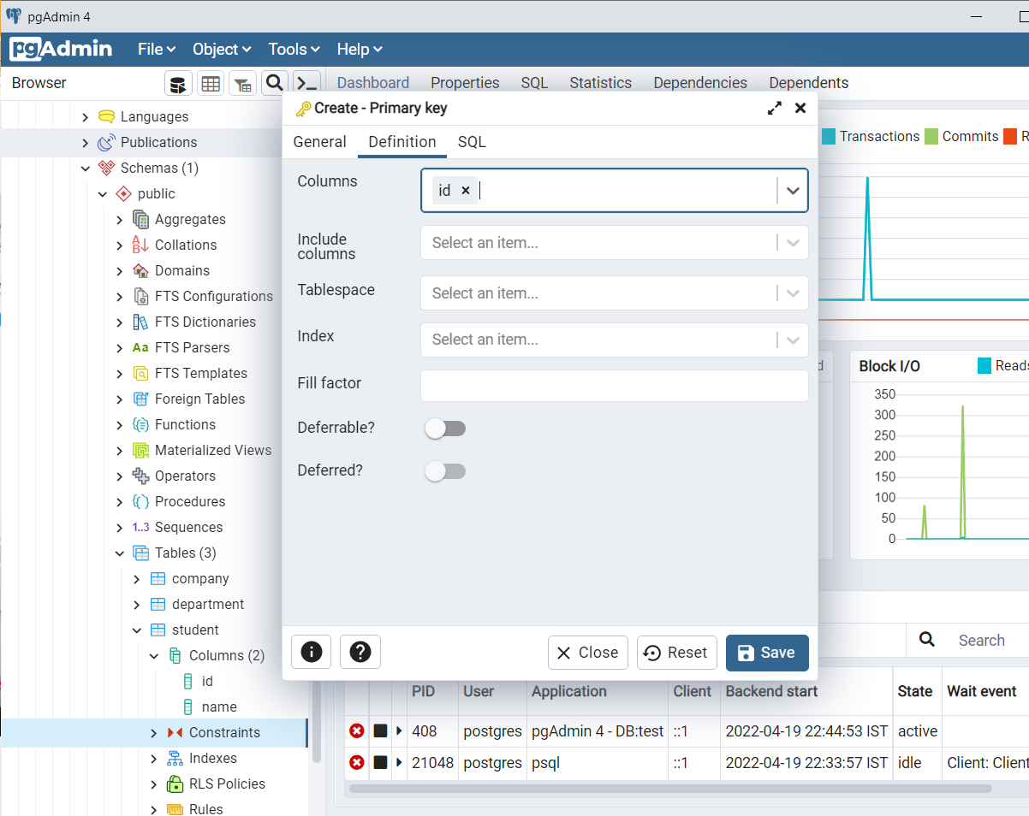

To write query use editor from tools.

Right click on tables red. To delete.

To delete a table use – drop table table-name;

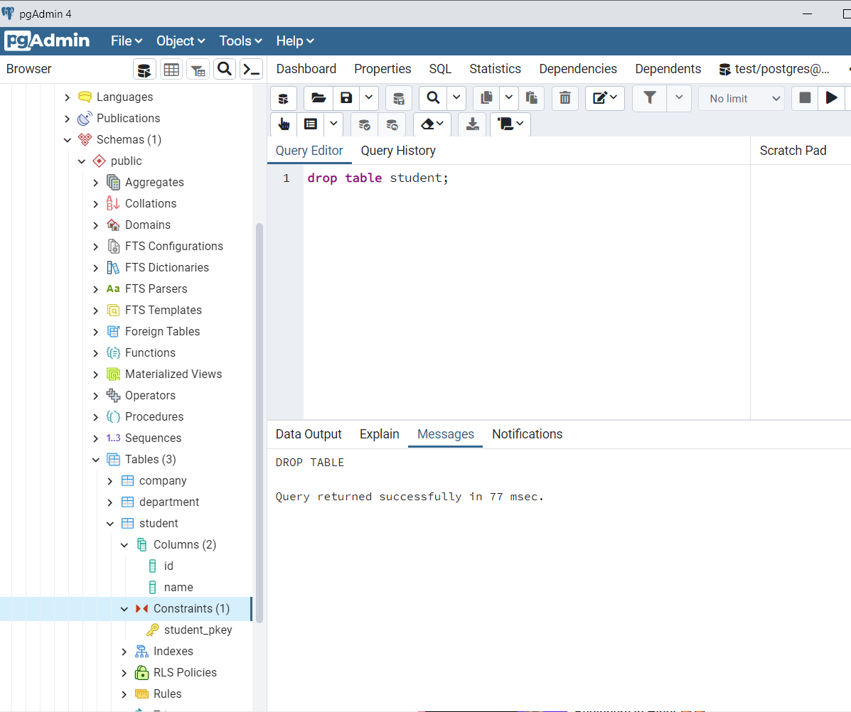

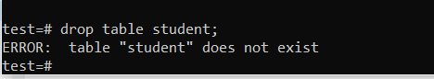

As done after doing from query editor.

insert into company(id,name,age,address,salary)values(7,'Rahul',20,'Kolkata',50000)

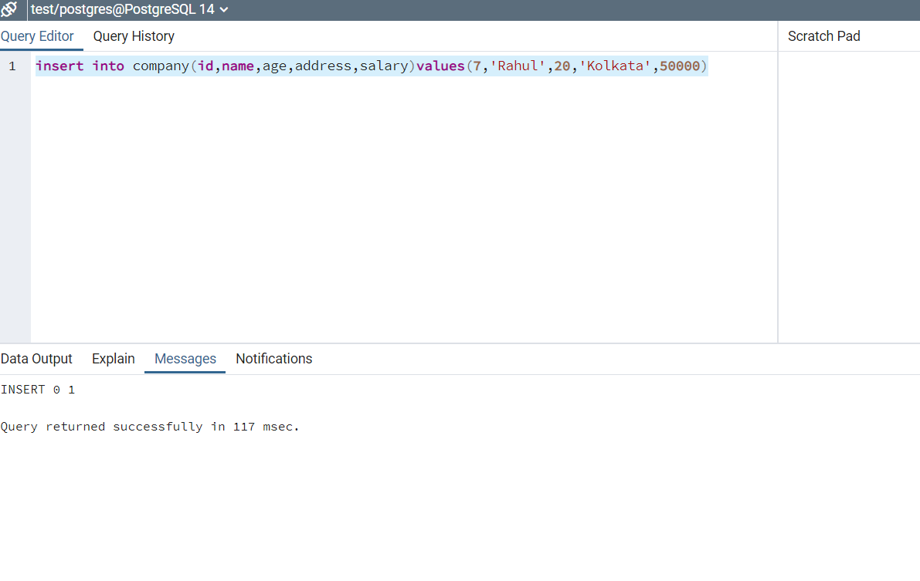

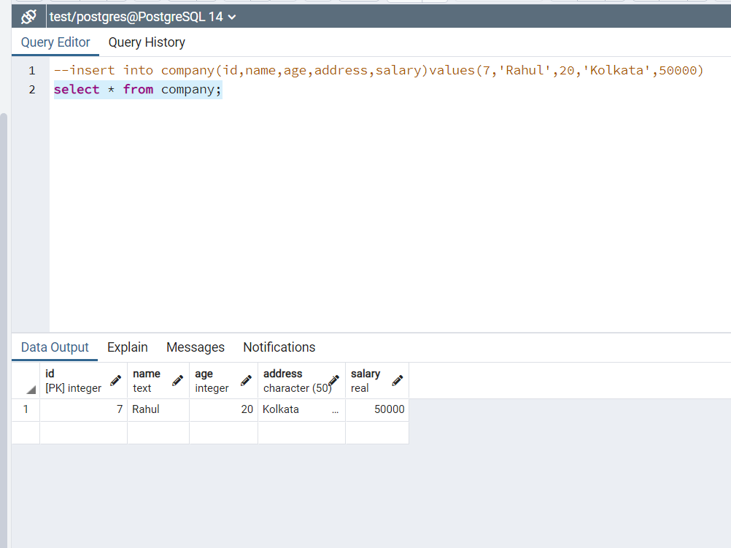

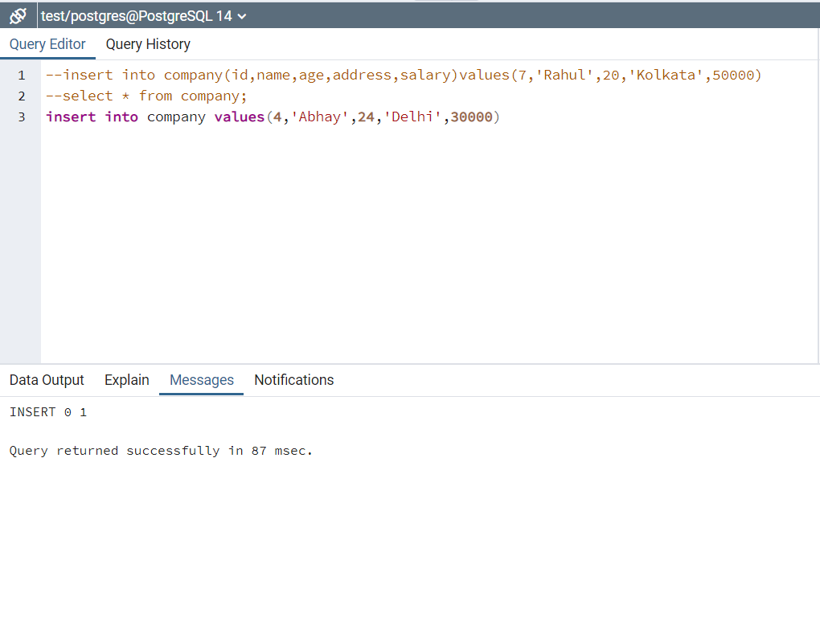

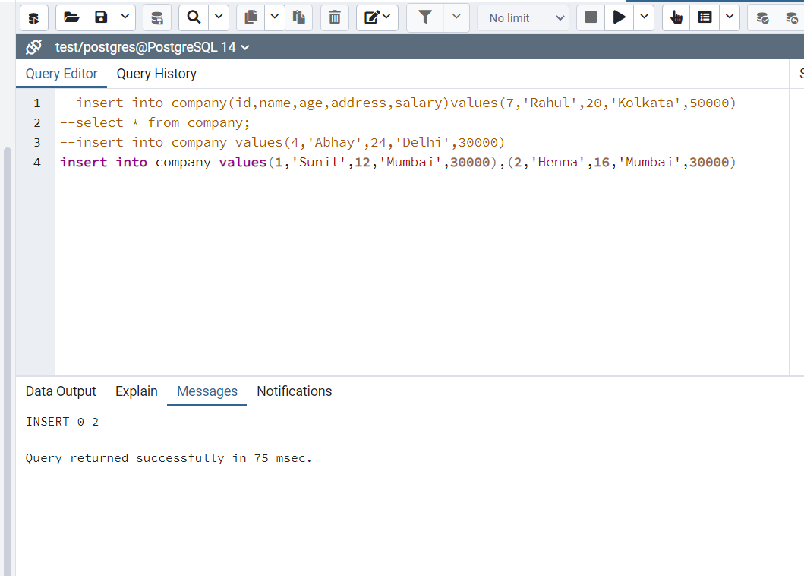

FORGOT SEMICOLON IN ABOVE STEPS NEED TO PUT SEMICOLON AFTER EACH QUERY.

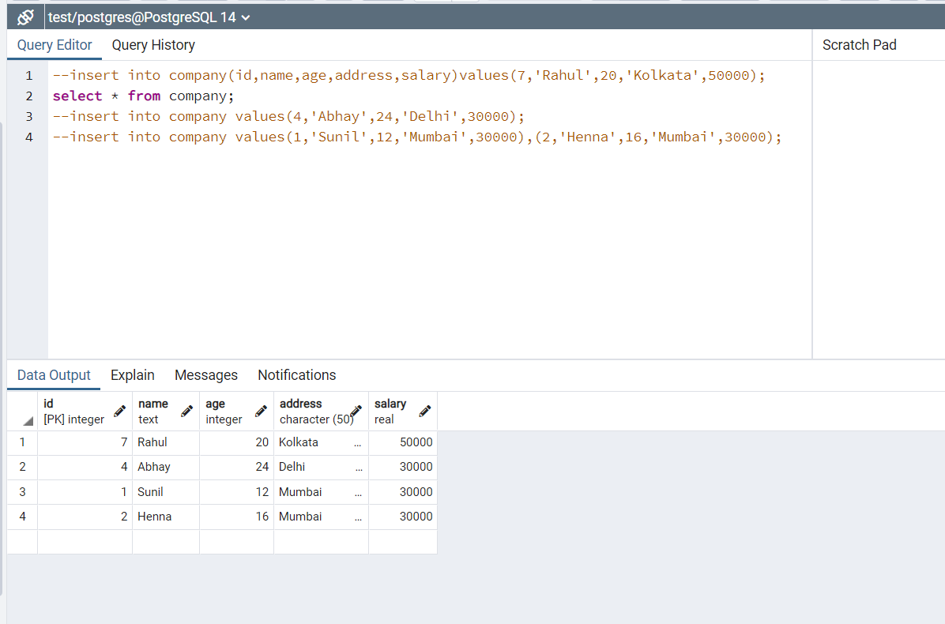

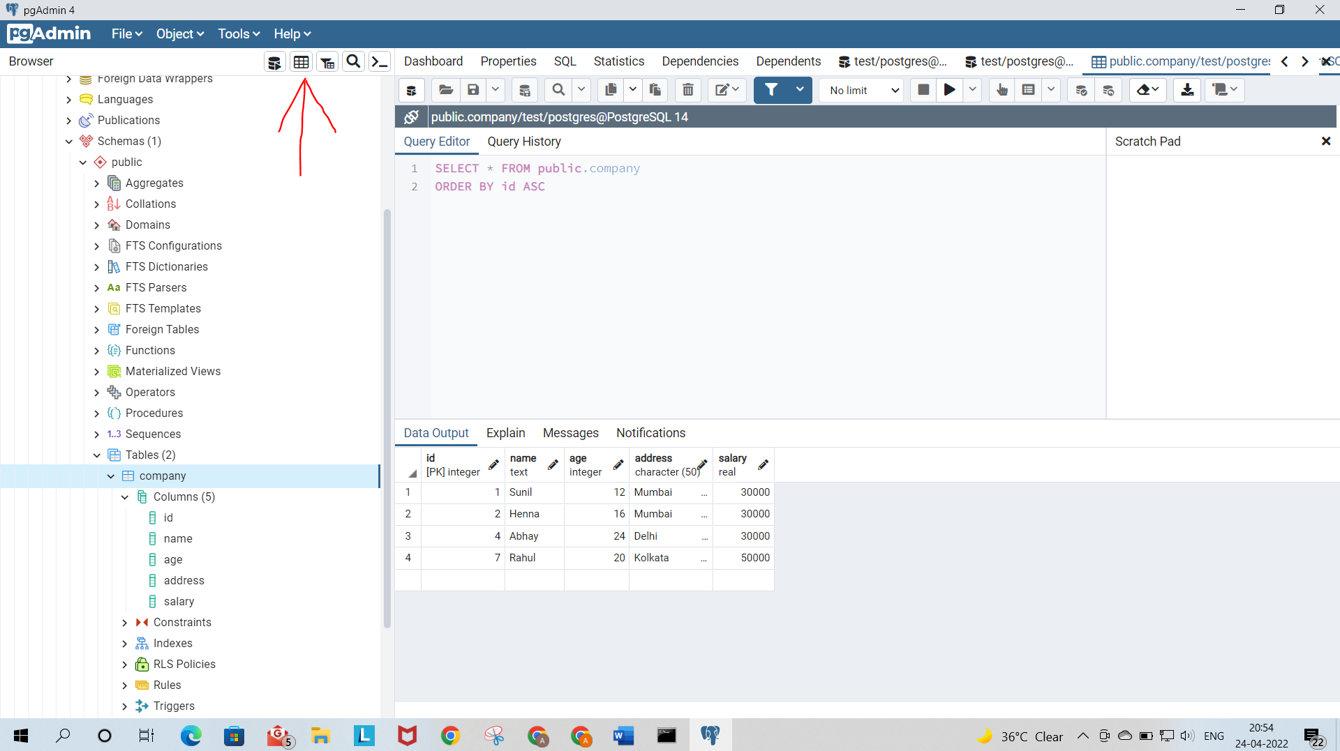

FOR VIEWING DATA IN THE TABLE SELECT COMPANY BY MOUSE AND CLICK ON VIEW DATA BUTTON MARKED BY ARROW. We Can also enter new data by clicking on the cells below.

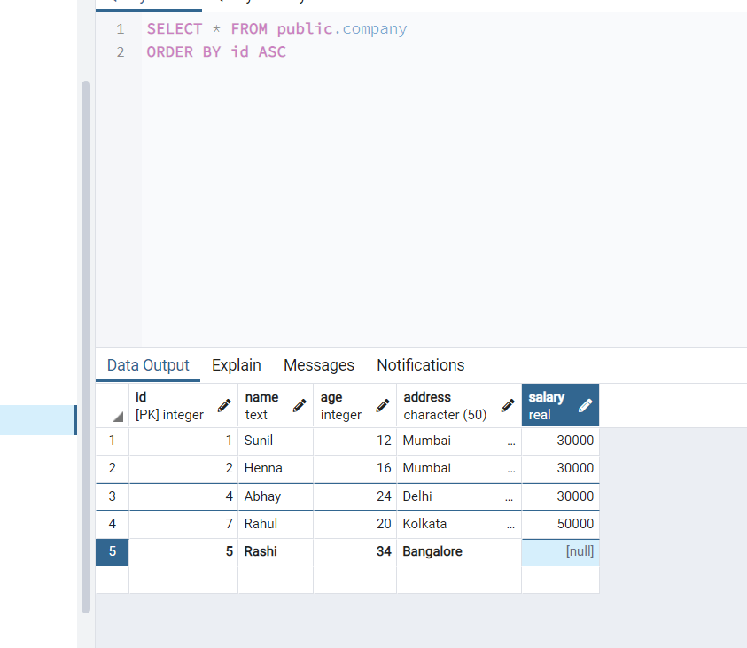

Make sure to save the data.

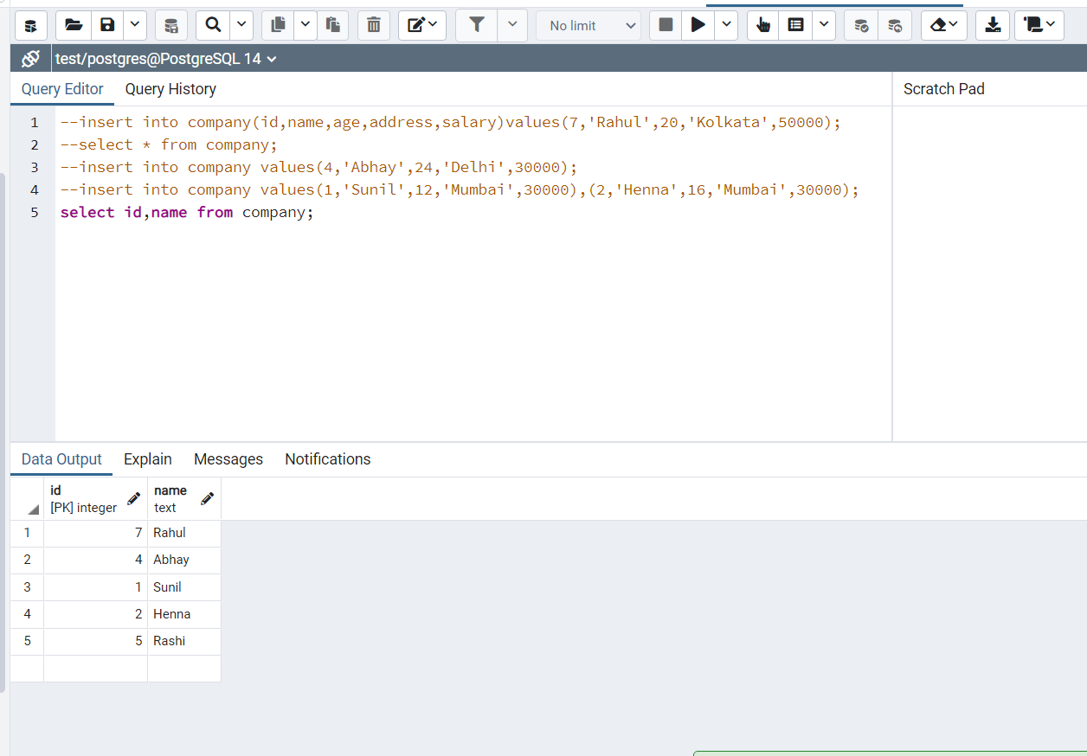

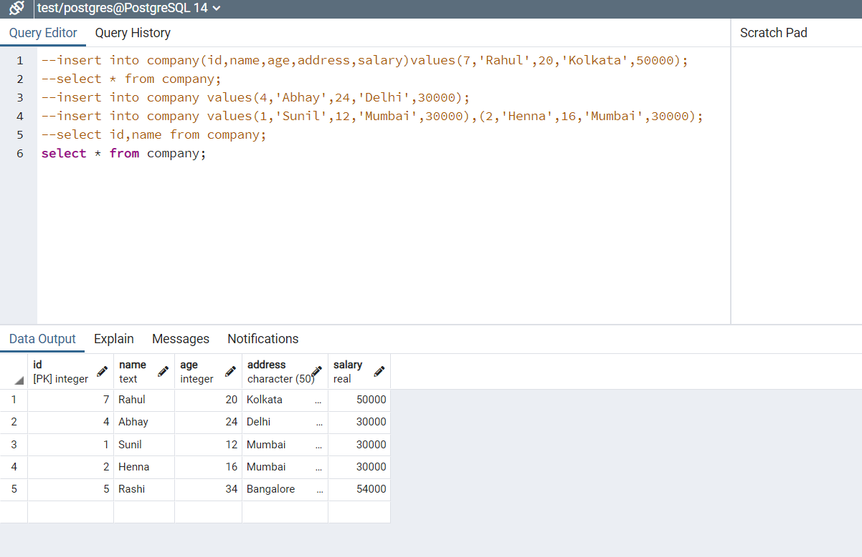

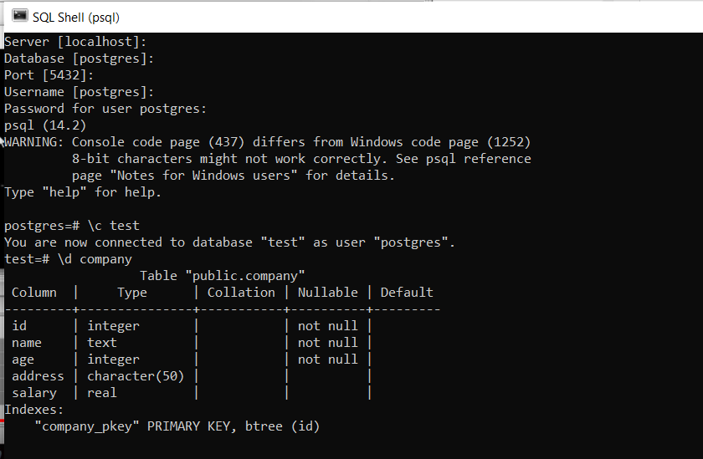

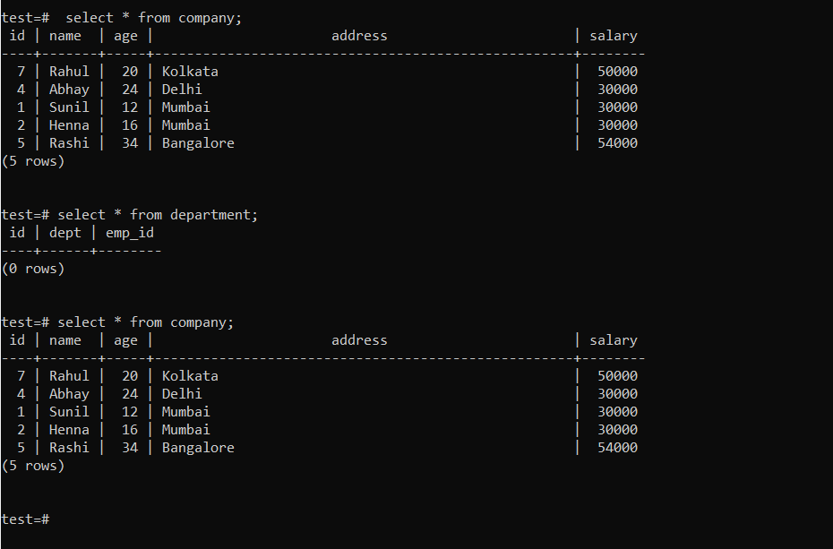

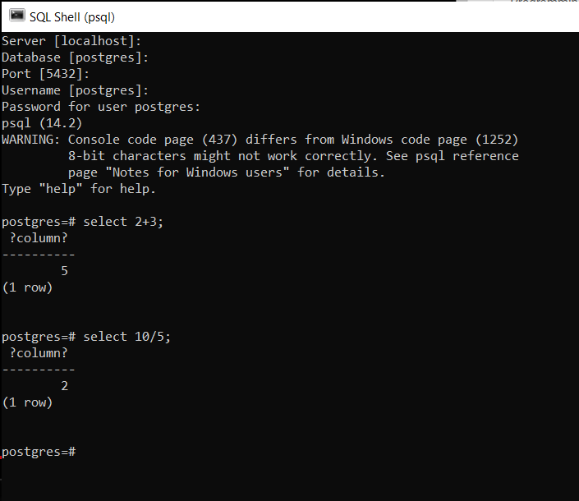



Above command to clear screen.

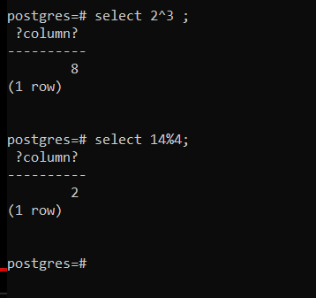

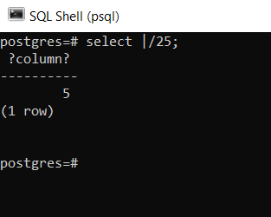

Square root of 25 is 5.

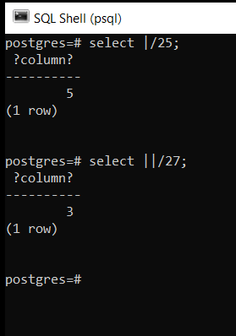

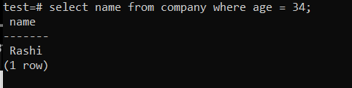

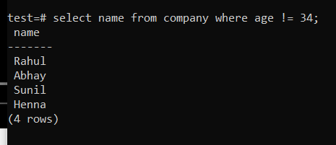

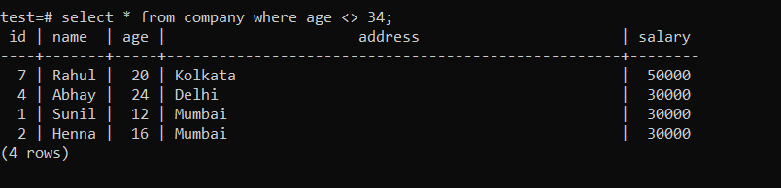

<> is equivalent to (not equal to) or != .

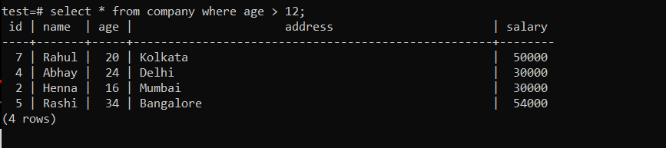

For greater than or equal to use 🡪 >= .

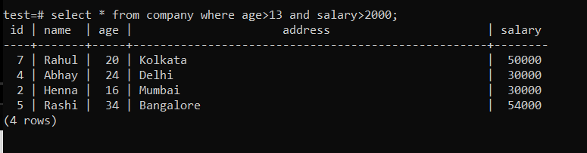

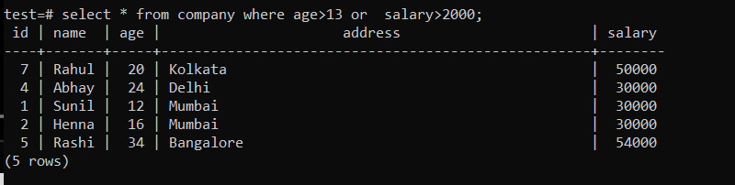

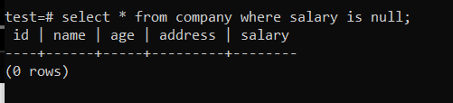

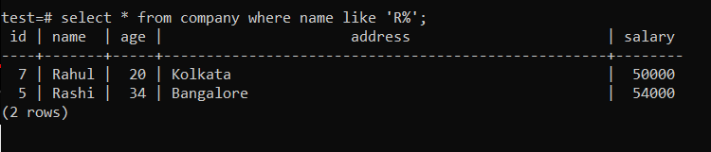

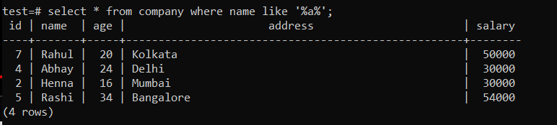

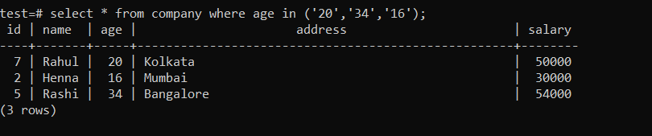

Above query means select row where age is 20 or 34 or 16.

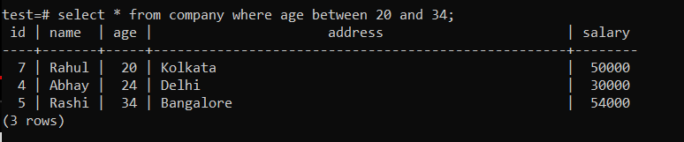

--- used for single line comment.

/*------------*/ used for multiline comment.

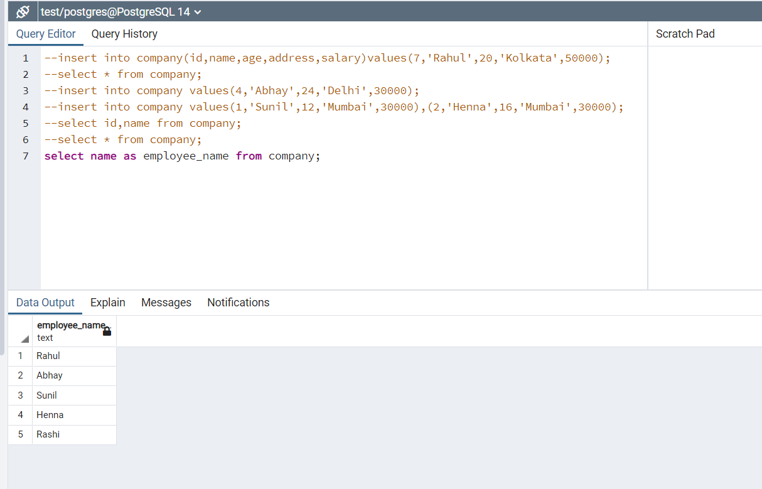

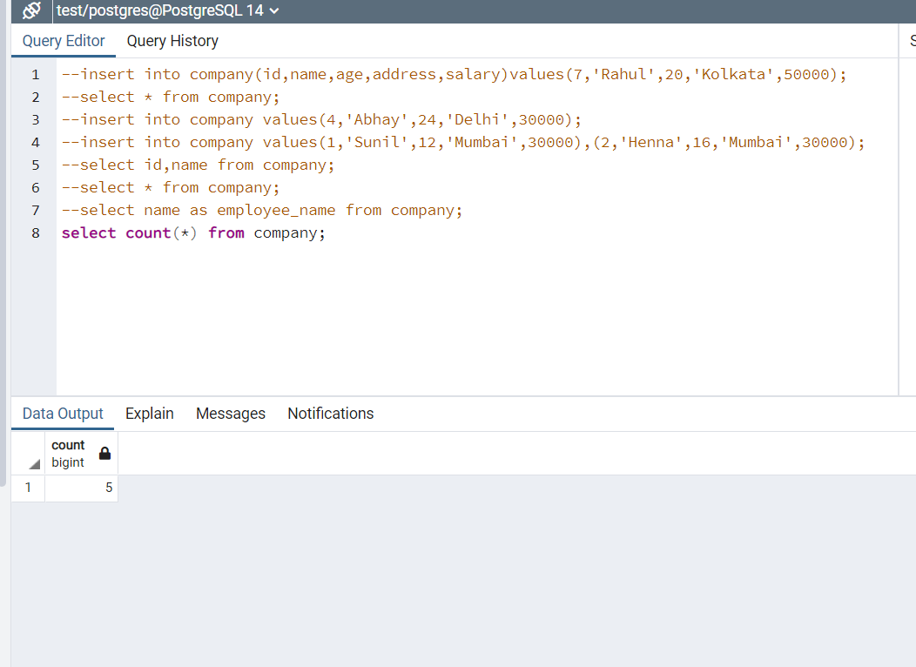

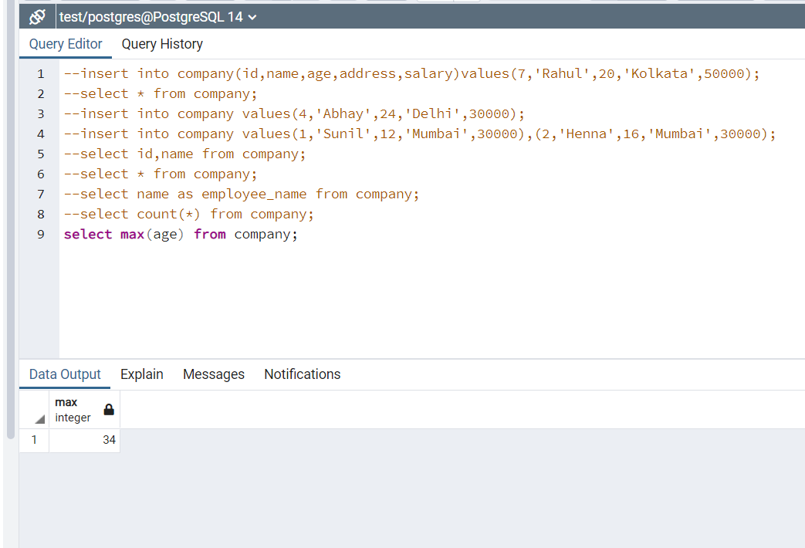

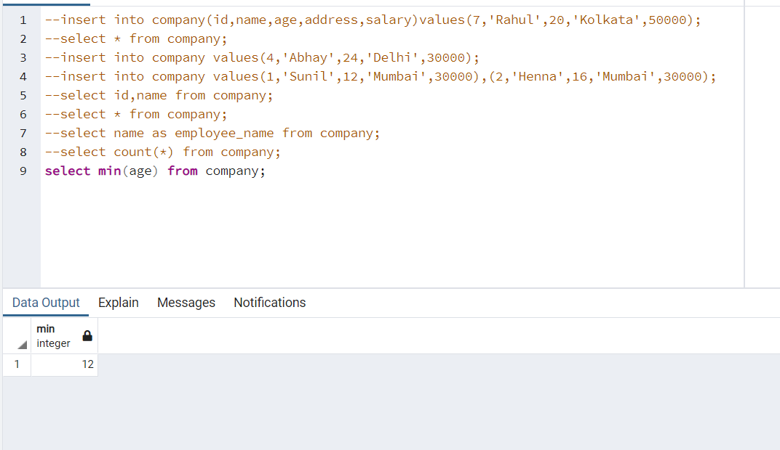

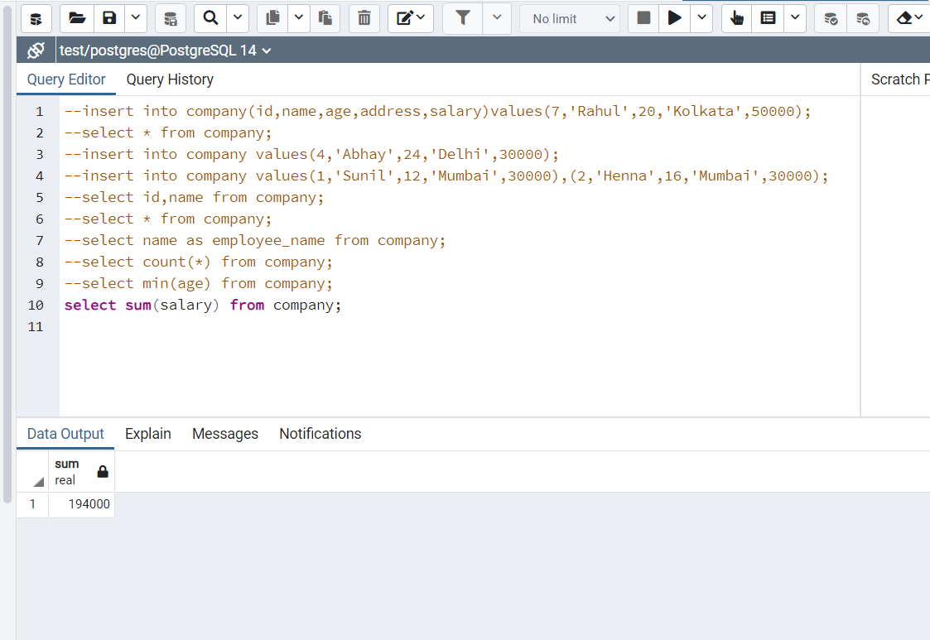

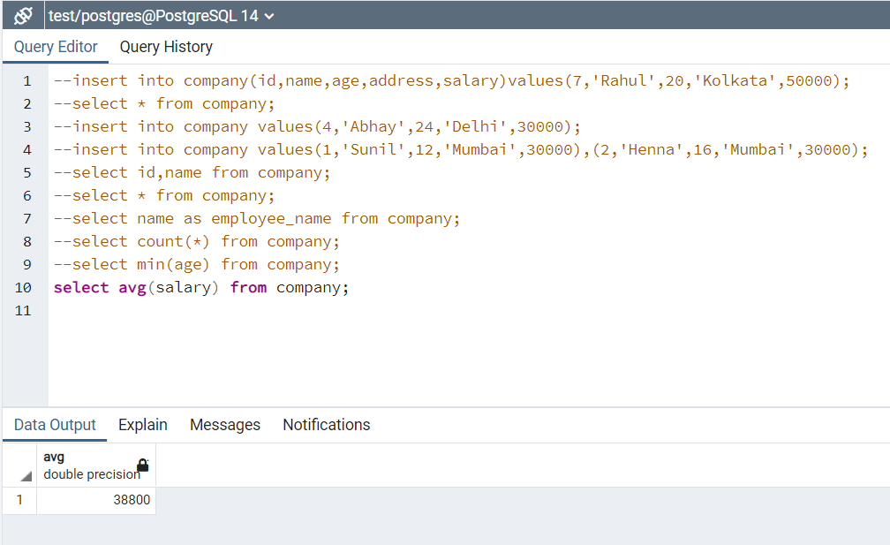

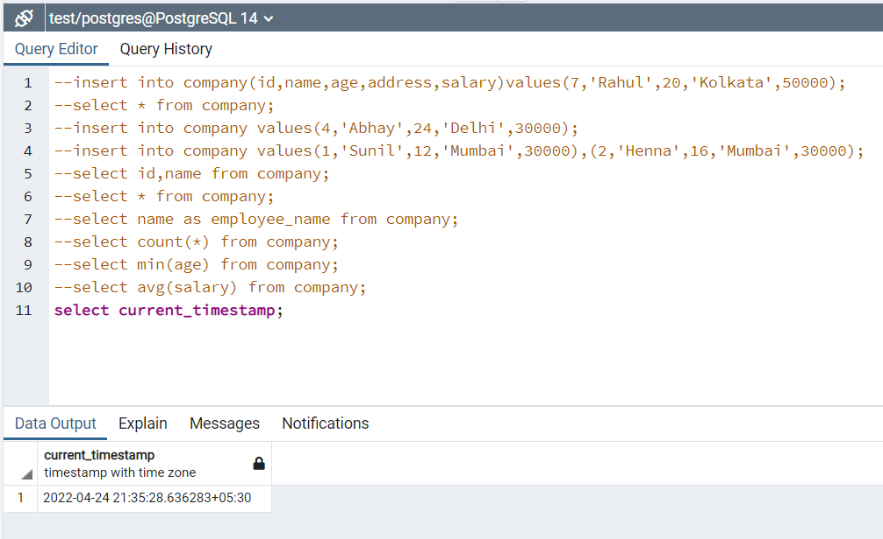

Above query to get current time,date etc.

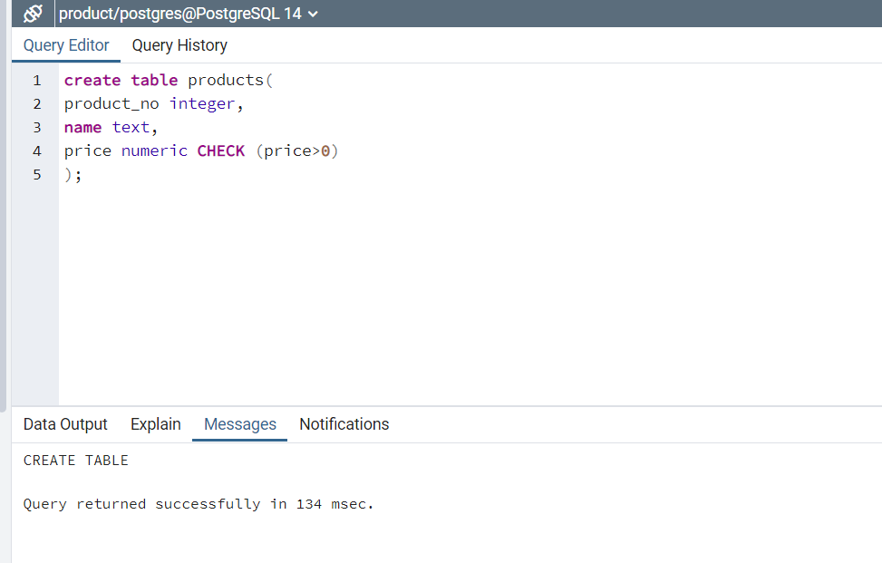

CHECK constraint to check for price always > 0.

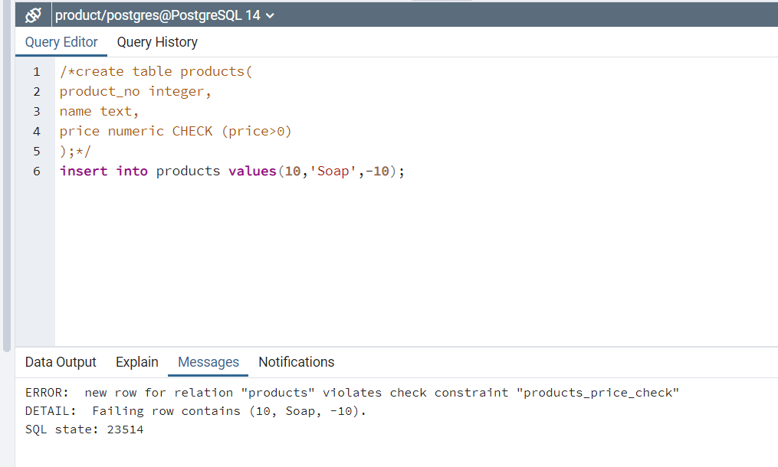

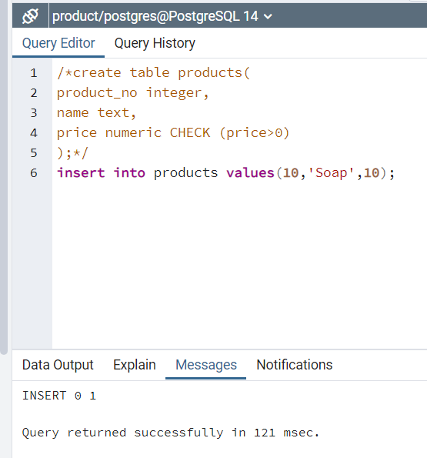

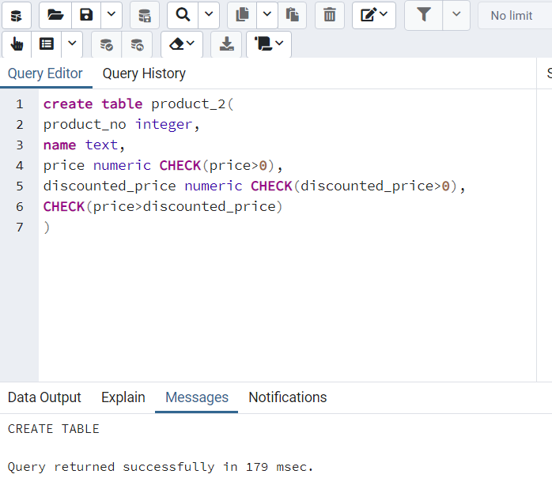

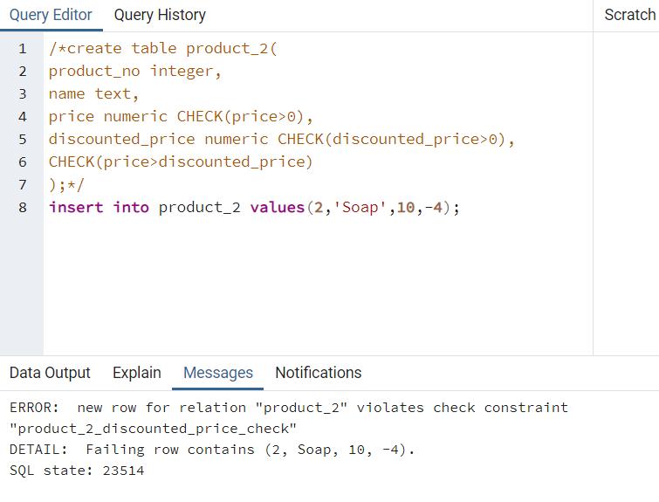

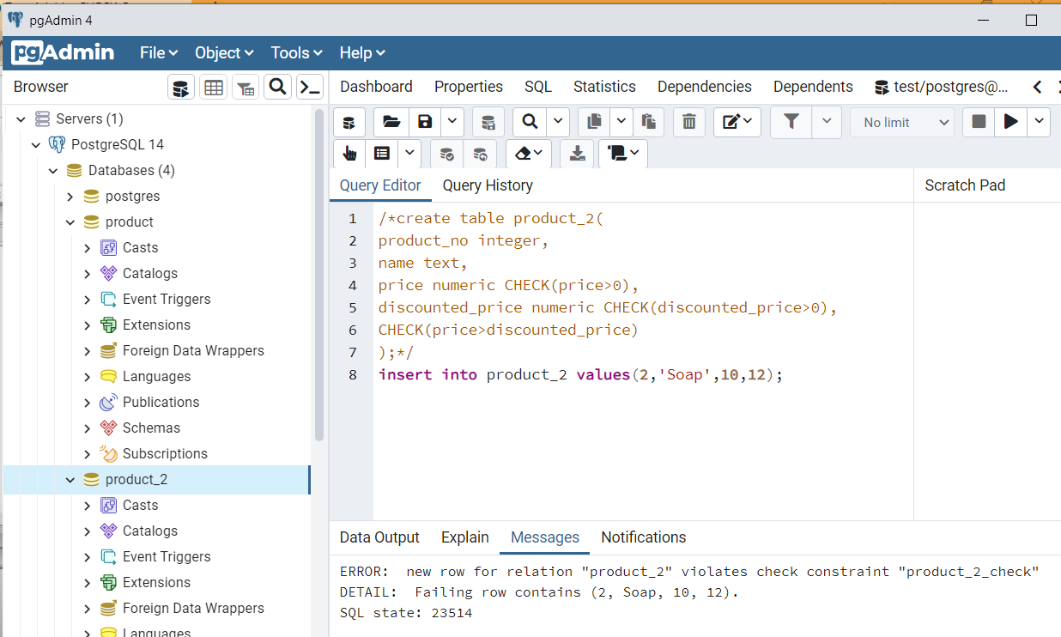

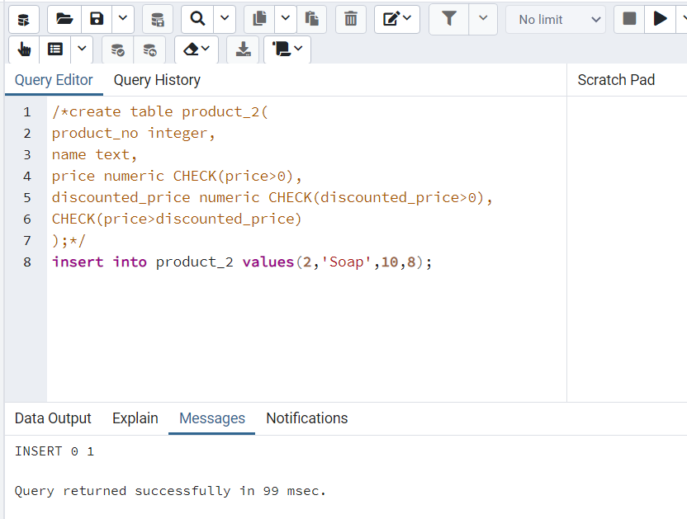

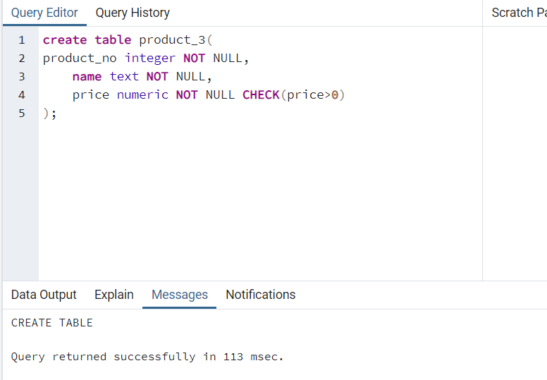

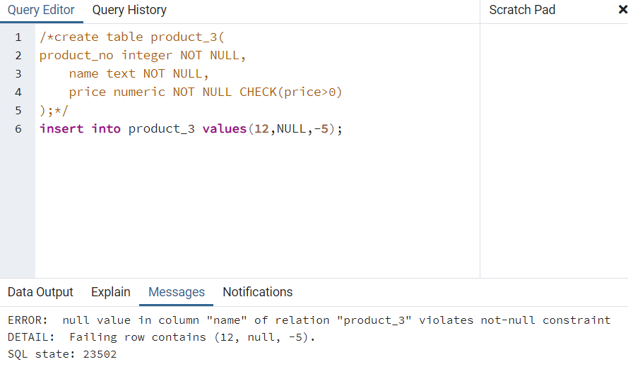

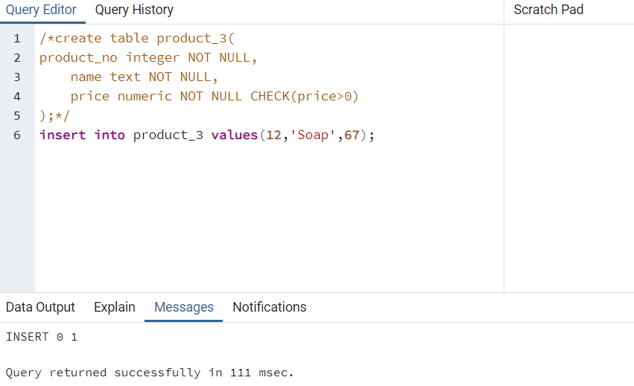

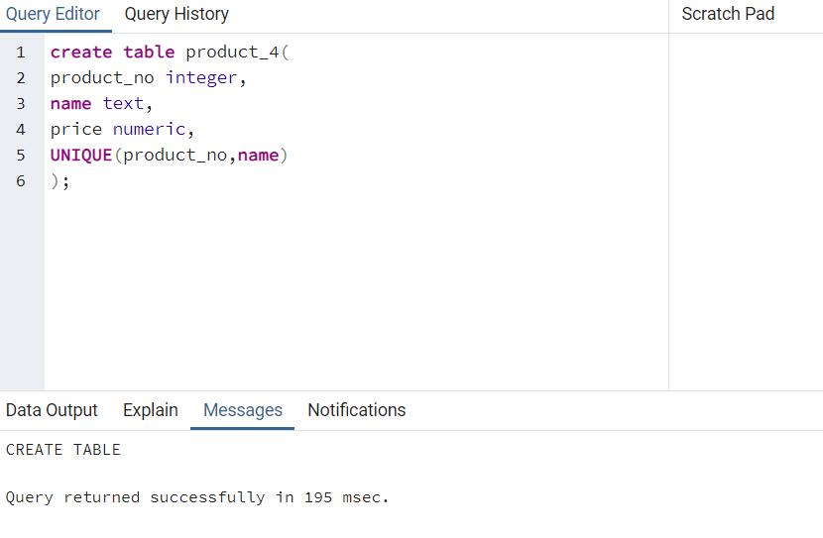

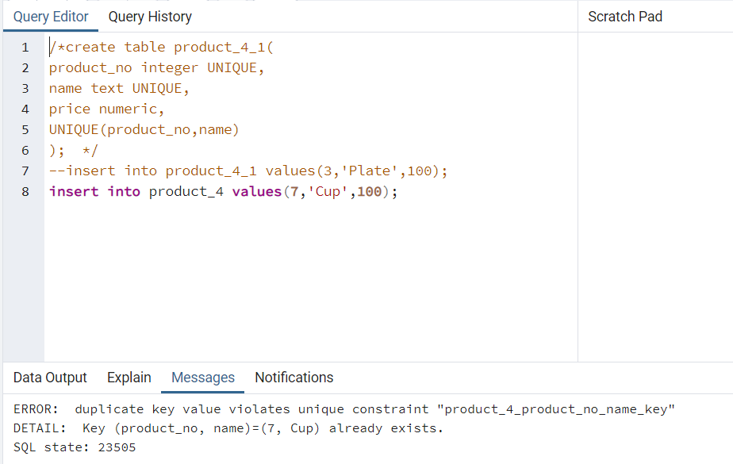

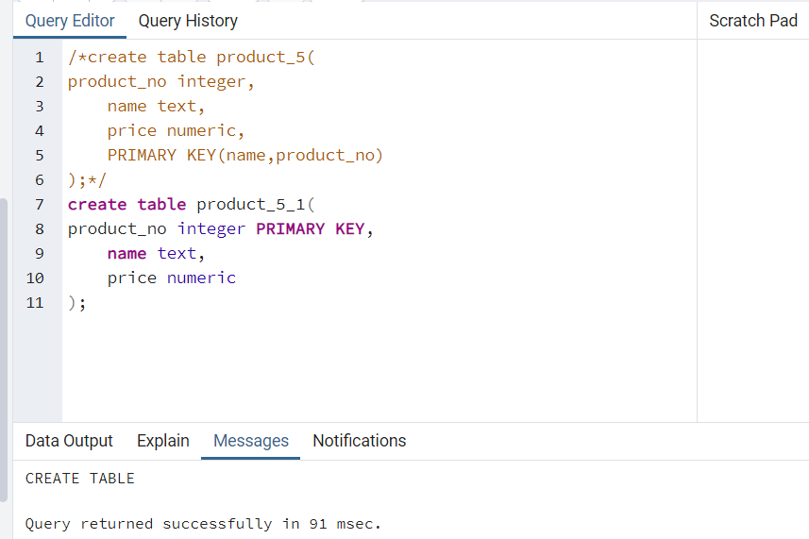

INSSERTING DATA BY🡪

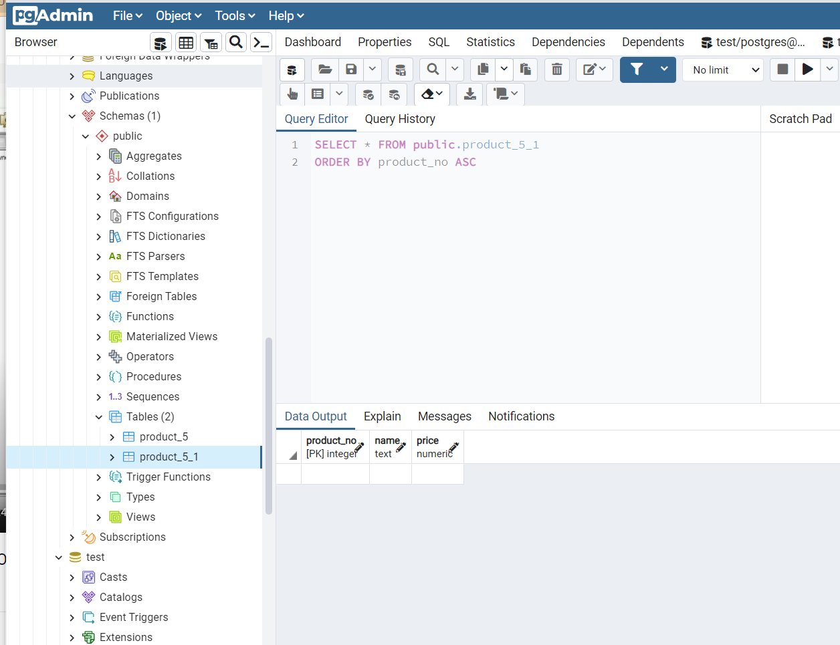

Error comes when order_id or product_no does not exist.

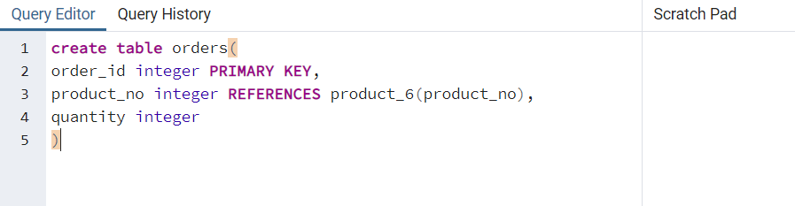

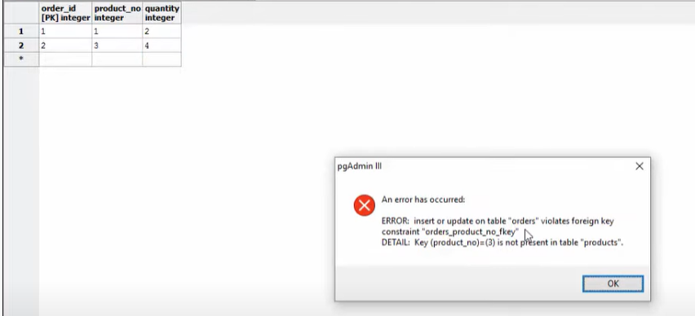

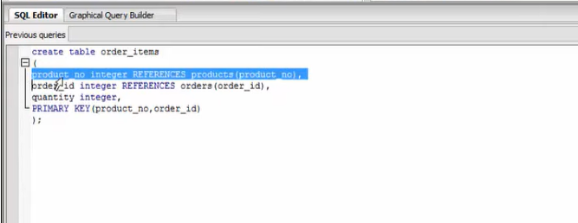

On Delete Restrict: **when data is removed from a parent table, and there is a foreign key associated with child table it gives error**, you can not delete the record.

ON DELETE RESTRICT means **you can't delete a given parent row if a child row exists that references the value for that parent row**. If the parent row has no referencing child rows, then you can delete that parent row.

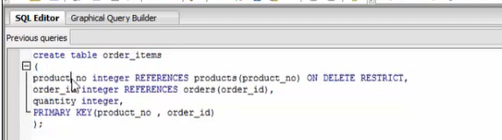

ON DELETE CASCADE clause is **used to automatically remove the matching records from the child table when we delete the rows from the parent table**. It is a kind of referential action related to the foreign key.

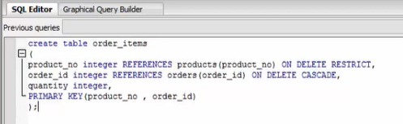

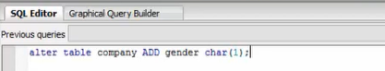

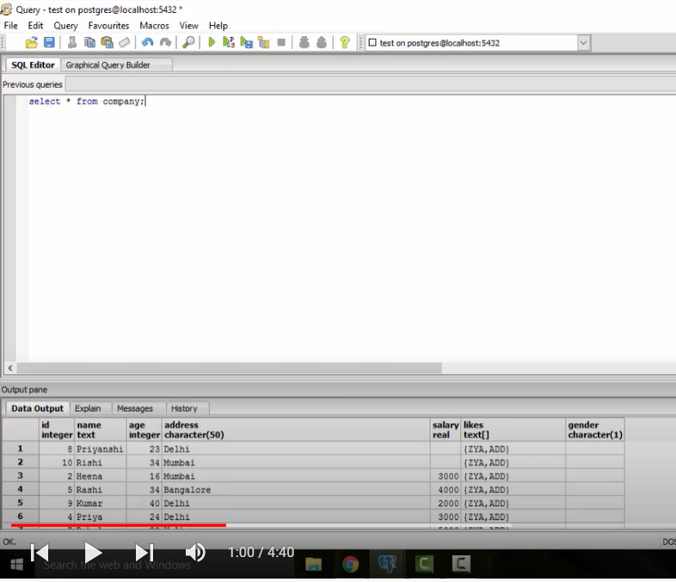

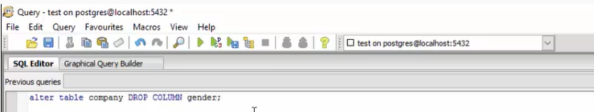

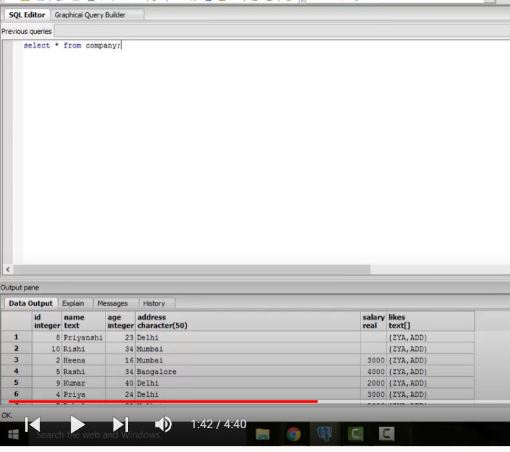

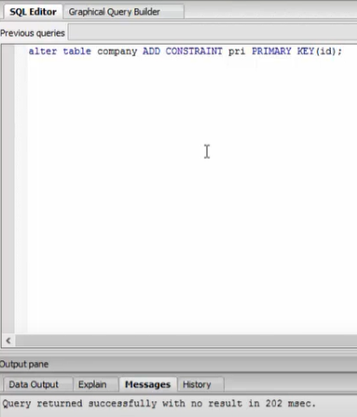

The above query used to add pri named primary key constraint .

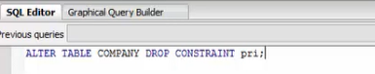

The above command to drop constraint pri.

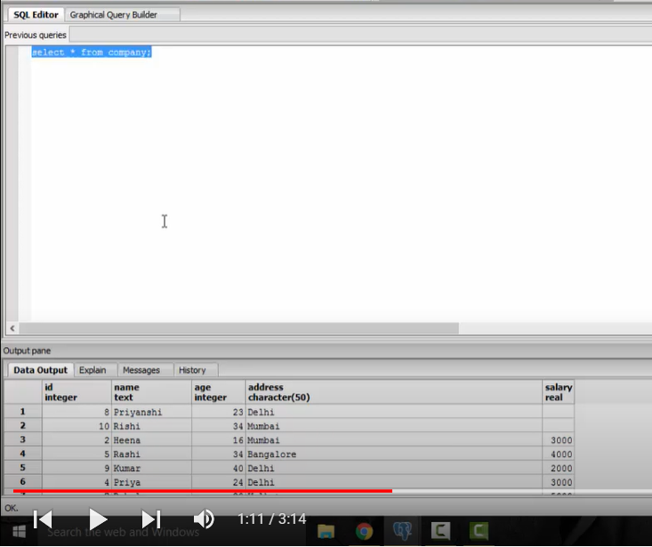

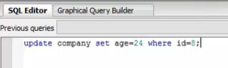

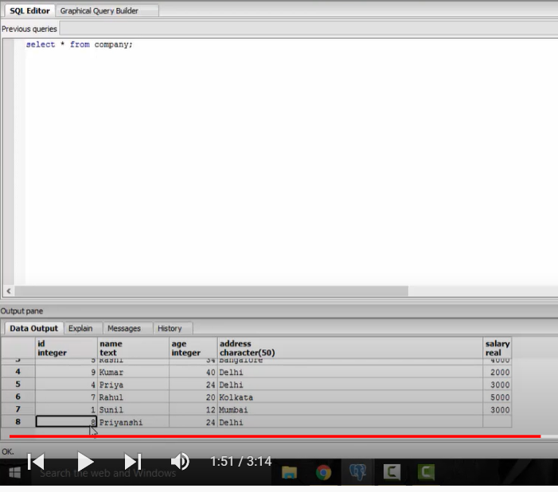

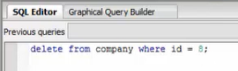

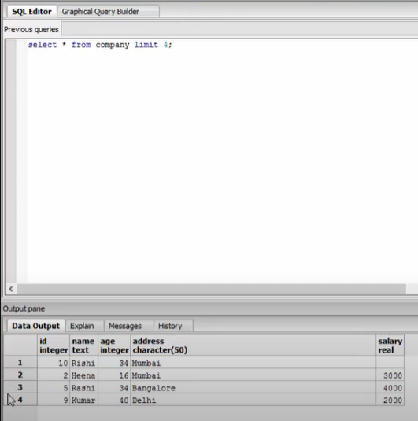

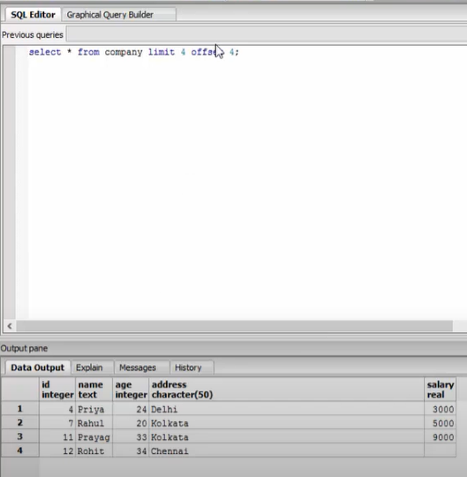

Limit 4 is used to get first 4. Offset 4 is used to get next 4 after first 4.

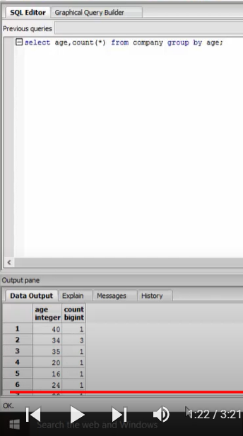

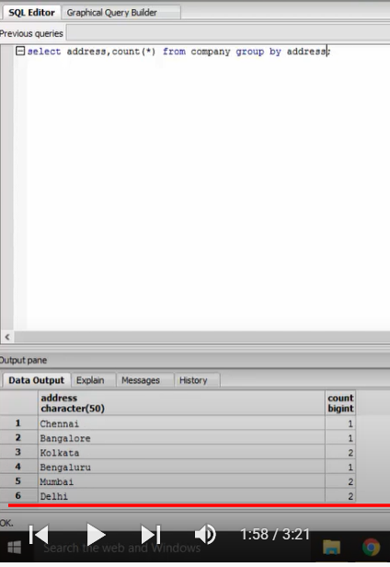

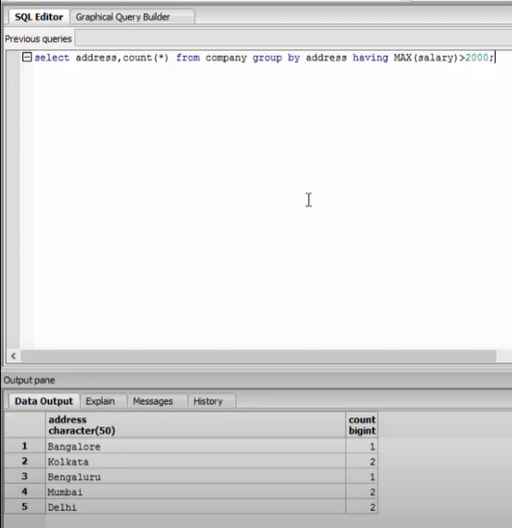

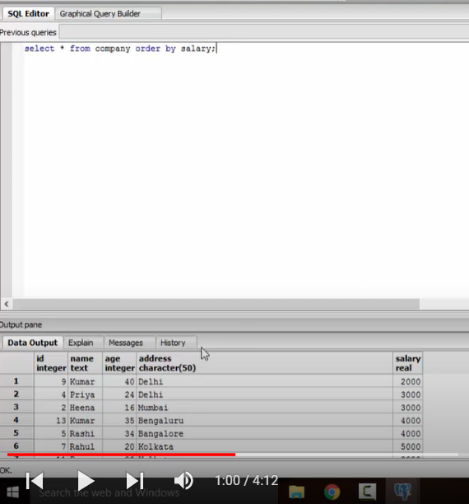

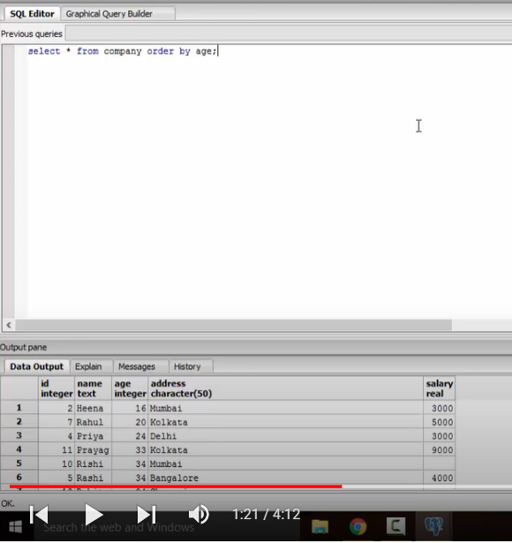

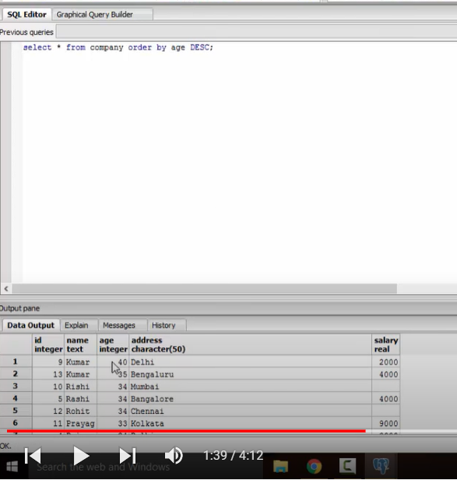

DESC FOR DESCENDING AND ASC FOR ASCENDING.

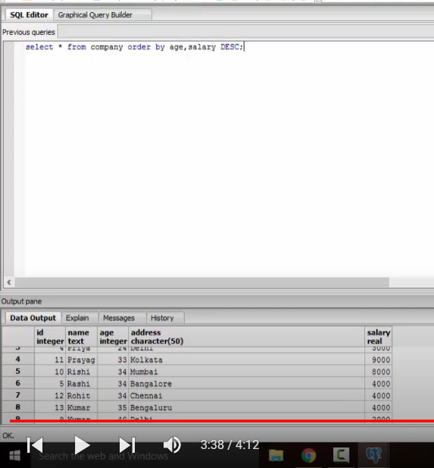

ORDERED BY AGE IN ASCENDING ORDER AND SALARY IN DESCENDING ORDER.

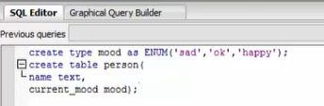

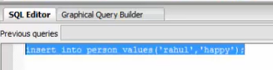

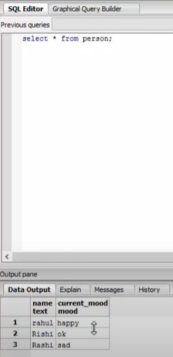

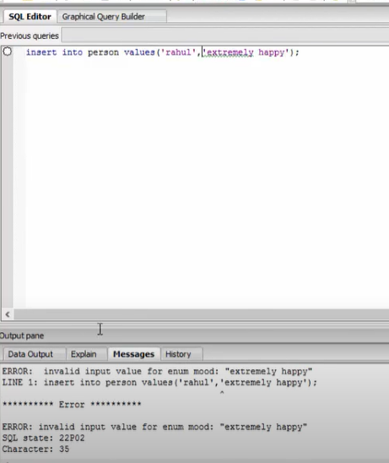

ERROR AS EXTREMELY HAPPY WAS NOT DECLARED IN THE ENUMERATION.

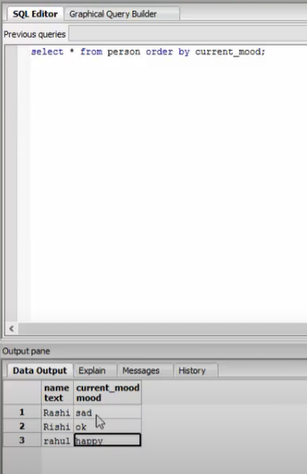

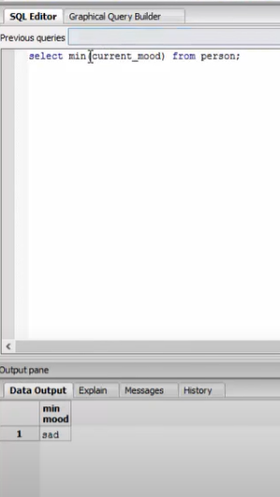

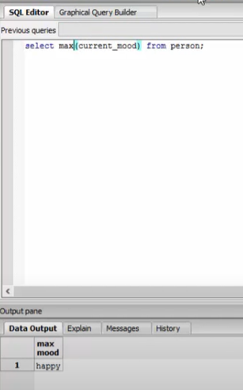

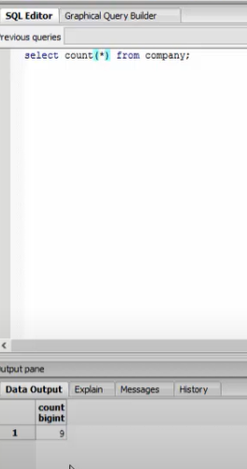

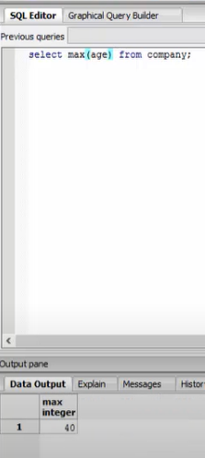

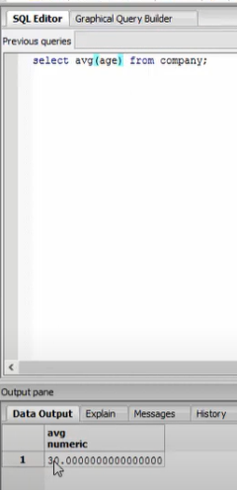

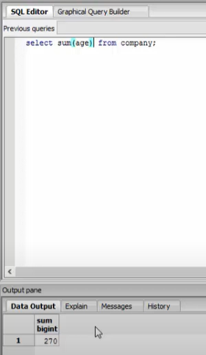

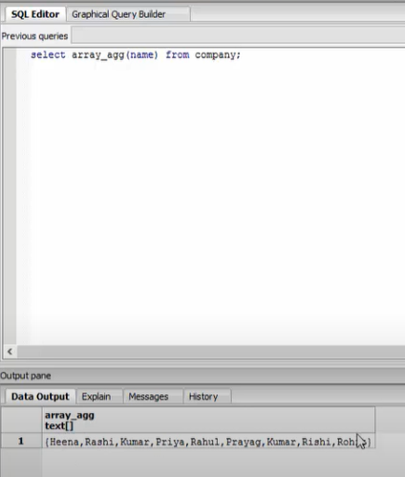

THE ABOVE QUERY RETURNS AN ARRAY OF NAMES FROM COMPANY TABLE.

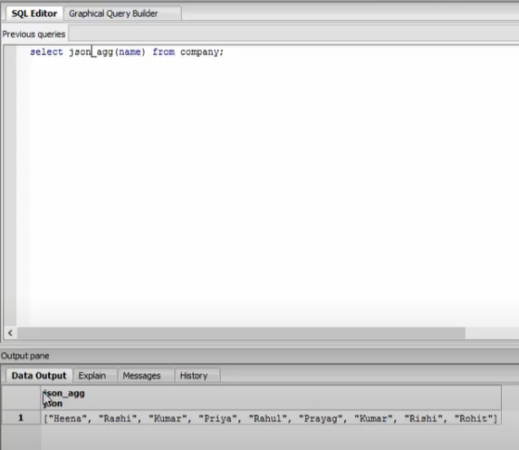

THE ABOVE QUERY GIVES JSON FORM OF OUTPUT OF NAMES.

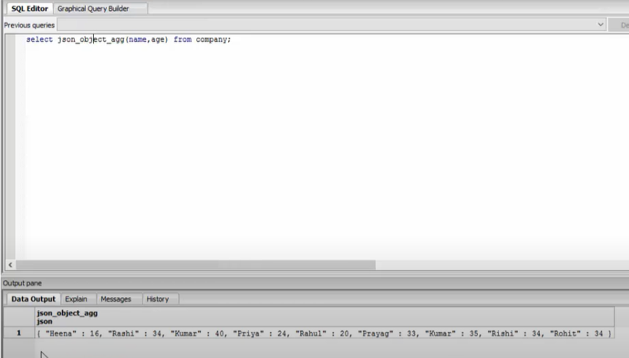

THE ABOVE QUERY GIVES KEY-VALUE FORMAT OF NAME AND AGE IN JSON FORMAT.

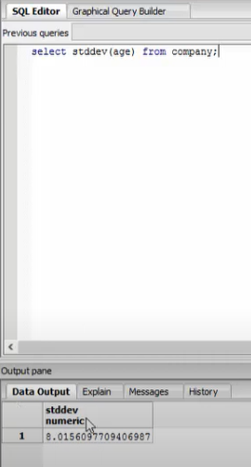

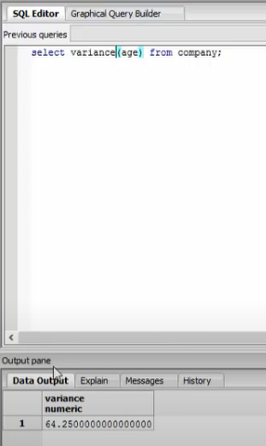

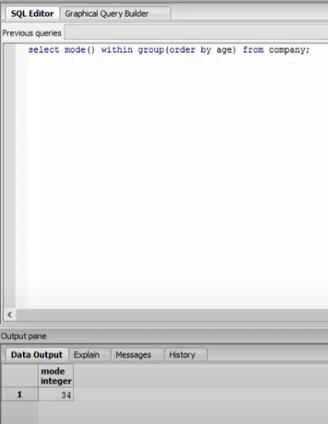

THE ABOVE QUERY RETURNS THE MOST OCCURING AGE IN THE COMPANY TABLE.

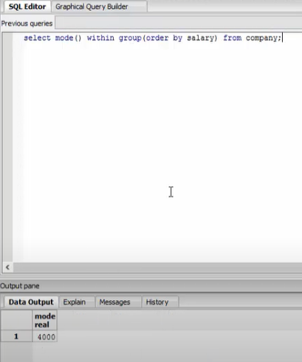

RETURNS THE MOST OCCURING SALARY FROM THE TABLE.

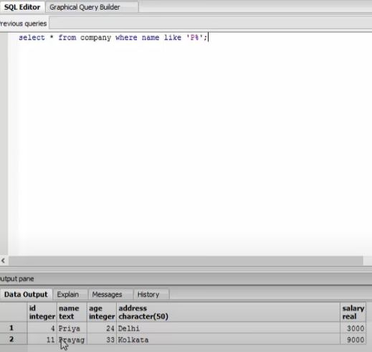

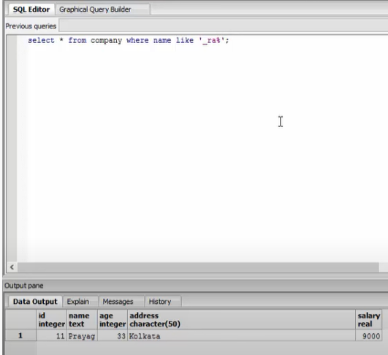

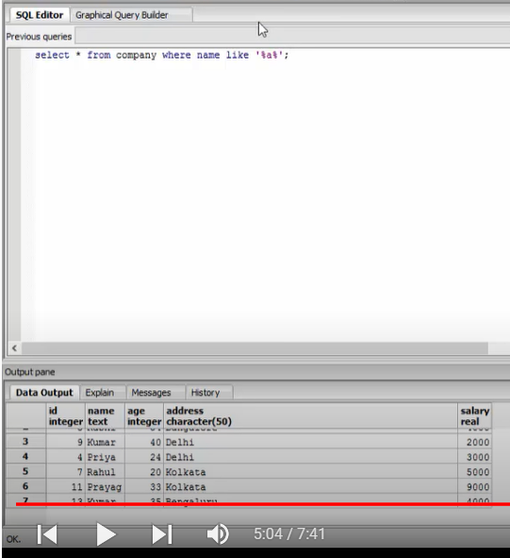

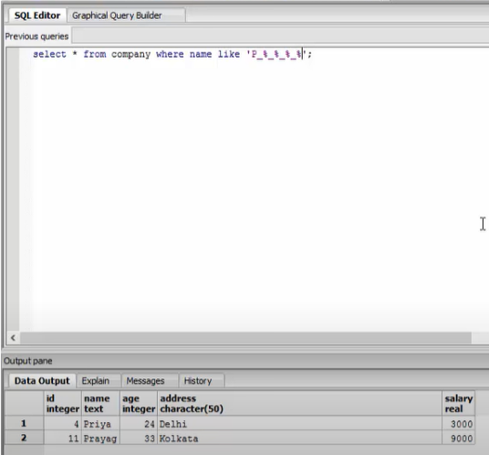

Name to be atleast 5 characters long.

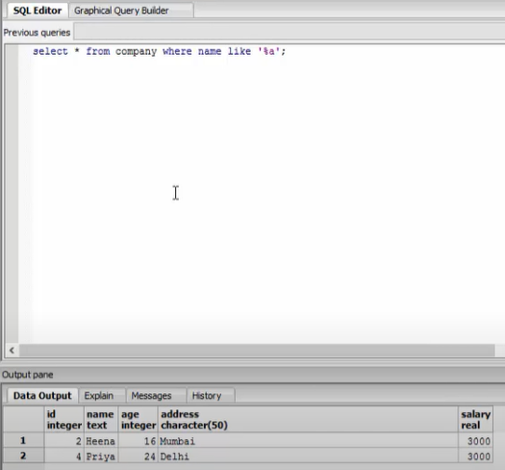

The above query for words ending with ‘a’.

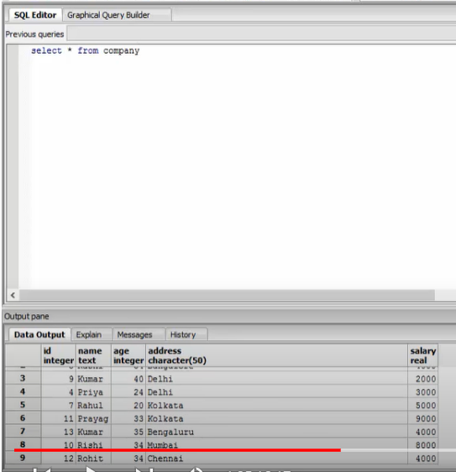

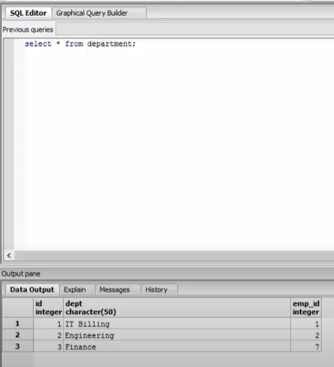

IF TABLE X HAS x ROWS AND TABLE Y HAS y ROWS THEN THE TABLE FORMED BY THEIR CROSS JOIN HAS x*y ROWS.

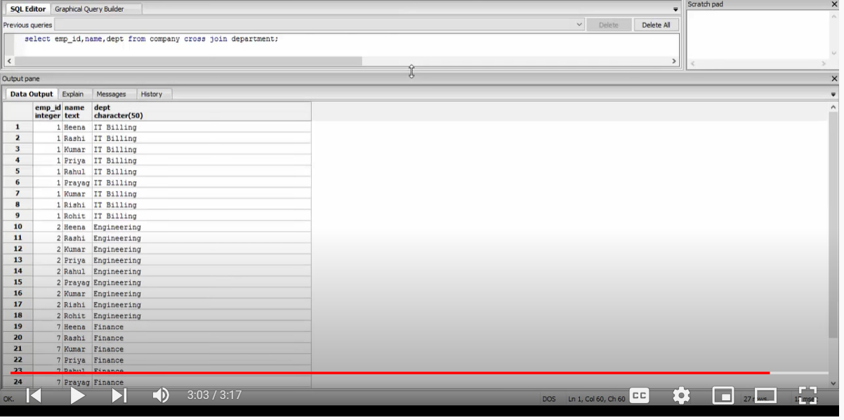

THE ABOVE TABLE FORMED BY CROSS JOIN HAS 9*3=27 ROWS.

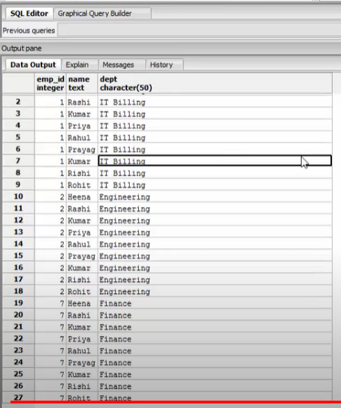

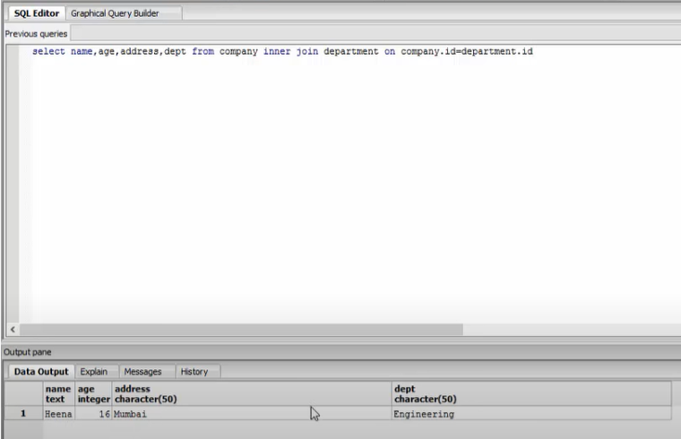

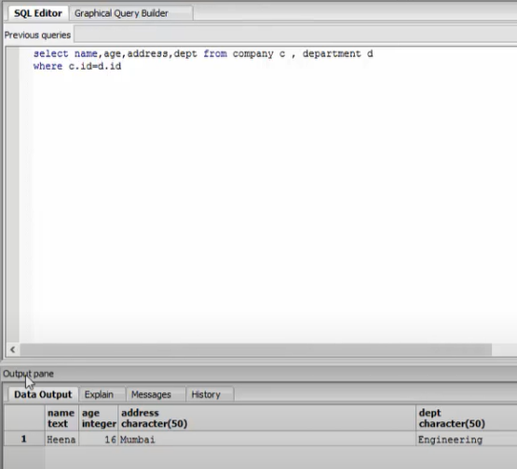

IN THE ABOVE 2 QUERIES NAME,AGE AND ADDRESS ARE FROM COMPANY TABLE AND DEPT FROM DEPARTMENT TABLE.

INNER JOIN RETURNS ONLY THE COLUMNS COMMON TO BOTH TABLES.

IN OUTER JOIN FIRST INNER JOIN IS DONE THEN THE VALUES THAT DON’T MATCH ARE REPLACED BY NULL VALUES.

X LEFT OUTER JOIN Y 🡪 MEANS ALL COLUMN VALUES OF X IS FULLY DISPLAYED BUT THOSE VALUES IN Y THAT DON’T MATCH WITH ANY ROW ARE KEPT NULL.

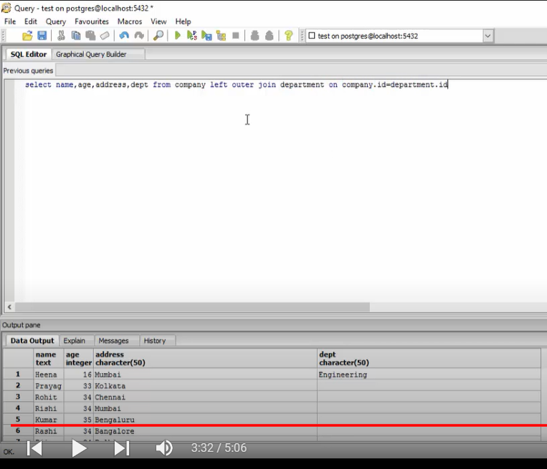

X RIGHT OUTER JOIN Y MEANS Y IS FULLY DISPLAYED BUT X VALUES THAT ARE NOT NOT COMMON TO ANY ROW OF Y IS DISPLAYED AS NULL.

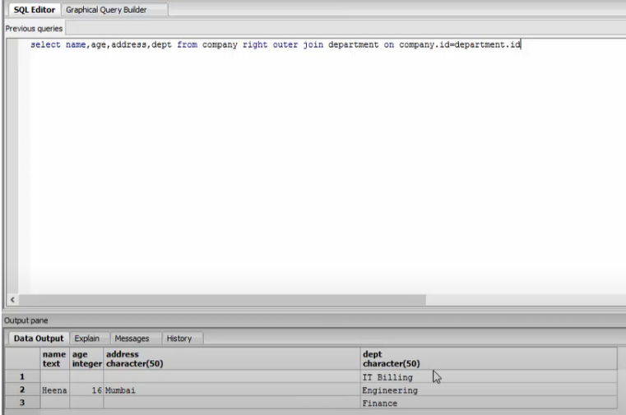

FULL OUTER JOIN HAS ALL VALUES FROM TABLE X AND Y AND EVEN FOR THOSE VALUES WHERE X OR Y IS NULL OUTPUT IS DISPLAYED.

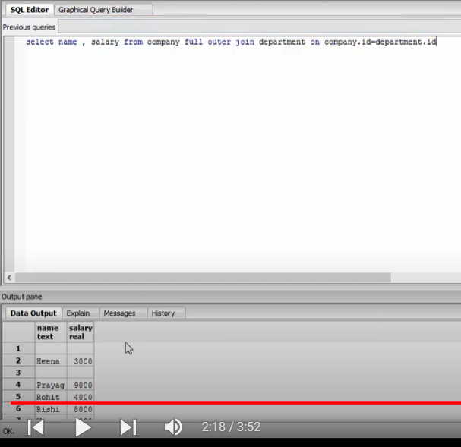

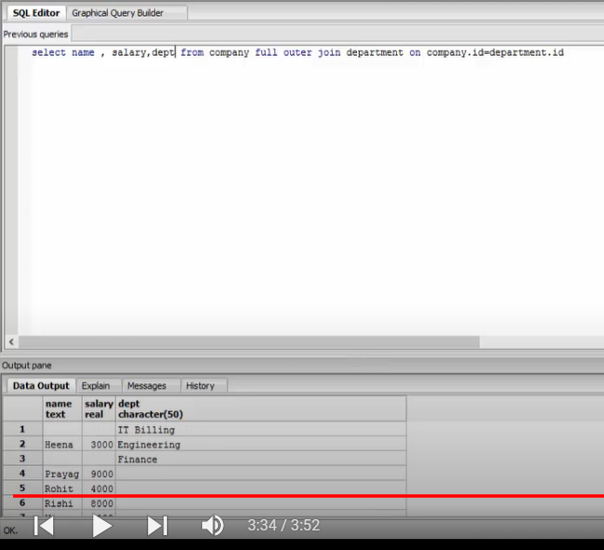

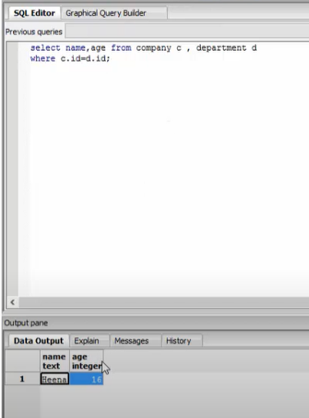

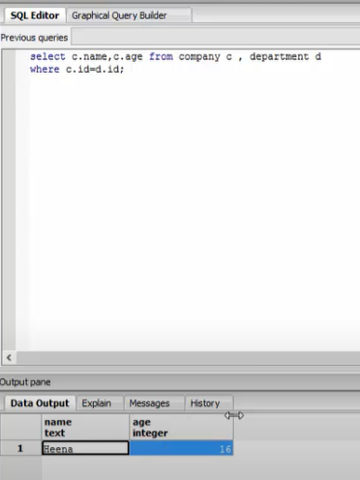

VIEWS ARE PSEUDO TABLES I.E NOT REAL TABLE OR PART OF TABLE . IT IS SUBSET OF TABLE AS IT SELECTS SOME COLUMNS AND ROWS FROM THE TABLE.

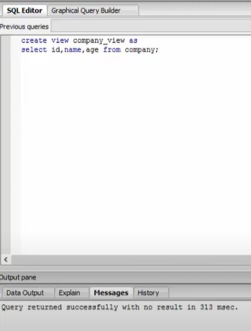

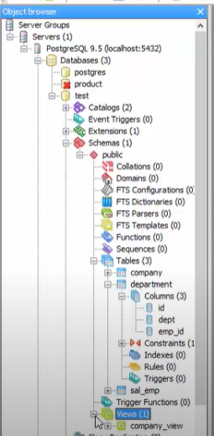

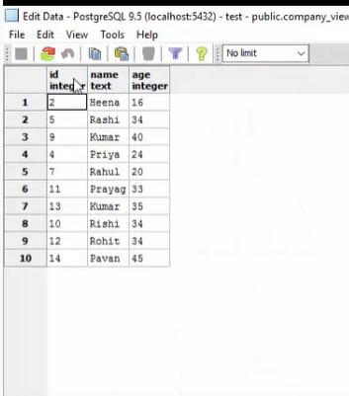

IN VIEWS WE CAN’T UPDATE, DELETE OR MODIFY DATA.

UNION OR UNION ALL IS USED TO COMBINE 2 SELECT STATEMENTS.

IN UNION IF WE HAVE ANY DUPLICATE ROWS THEN IT CAN BE COMBINED INTO SINGLE ROW.

IN UNION ALL WE CAN SEE DUPLICATE ROWS AND THEY ARE PART OF RESULT.

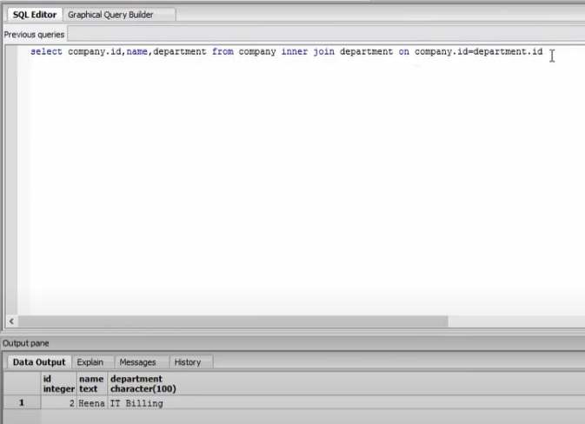

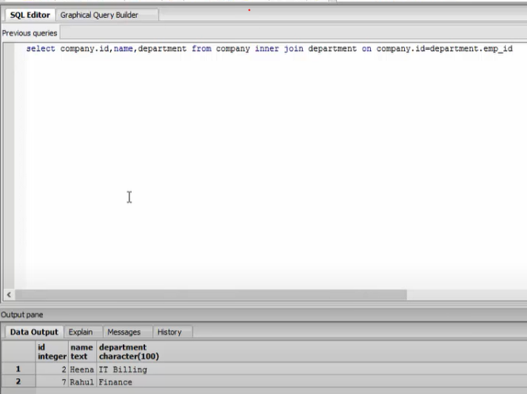

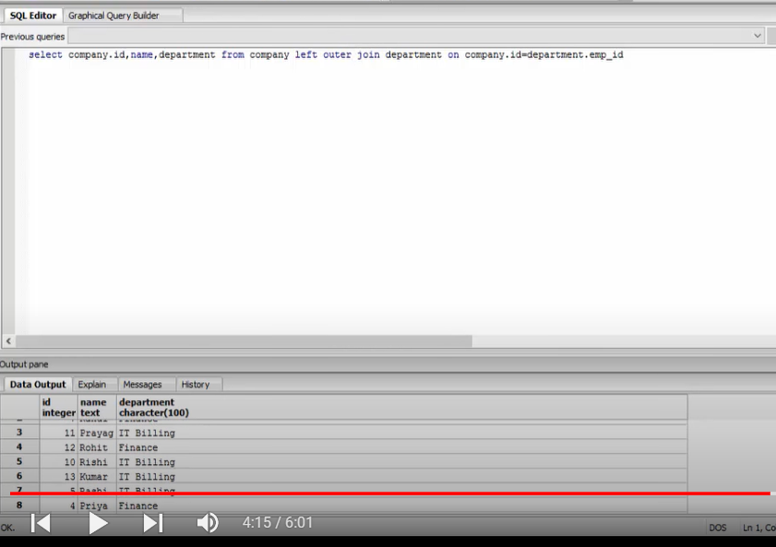

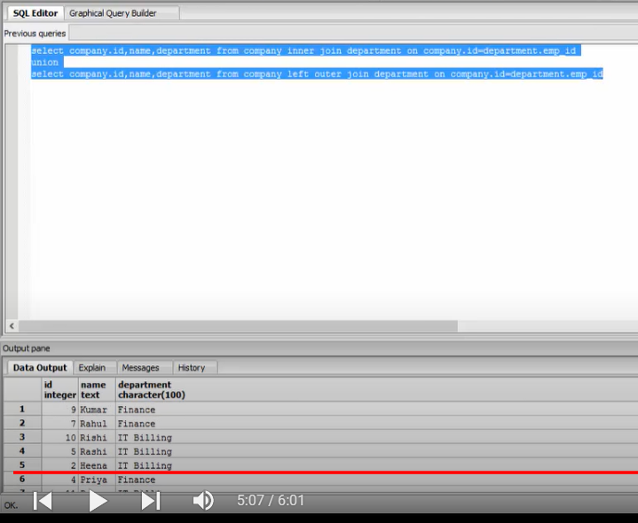

THE ABOVE QUERY IS FOR COMBINING OUTPUTS DUE TO INNER JOIN AND LEFT OUTER JOIN.

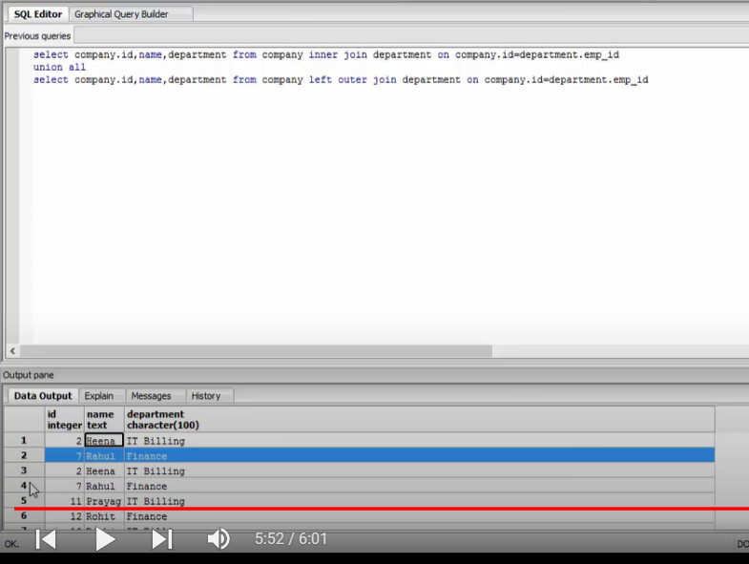

UNION ALL SHOWS DUPLICATE ROWS ALSO. EG IN ABOVE TABLE RAHUL,HEENA ROWS ARE DUPLICATED.

UNION DOES NOT HAVE DUPLICATE ROWS BUT UNION ALL HAS DUPLICATE ROWS.

TRUNCATE IS USED TO DELETE ALL DATA INSIDE ROWS AND COLUMNS OF TABLE BUT STRUCTURE OF TABLE REMAIN AS IT IS.

DROP TABLE -> USED TO DELETE TABLE STRUCTURE AS WELL AS DATA.

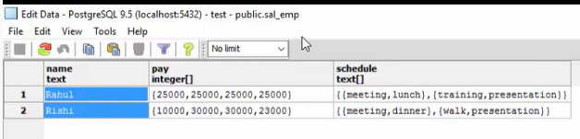

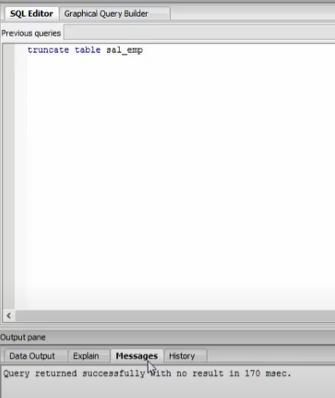

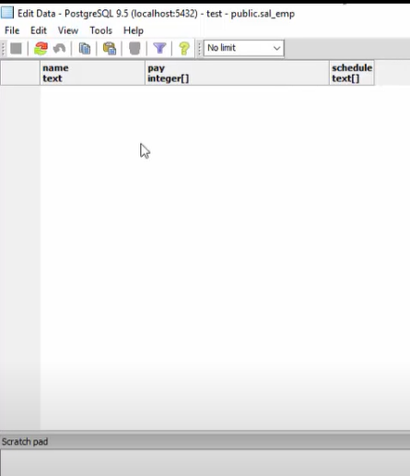

TRUNCATED CASCADED MEANS IF ANY FOREIGN KEY ASSOCIATED WITH PARENT TABLE THEN IF PARENT TABLE IS DELETED THEN FOREIGN KEY ASSOCIATED IS ALSO DELETED.

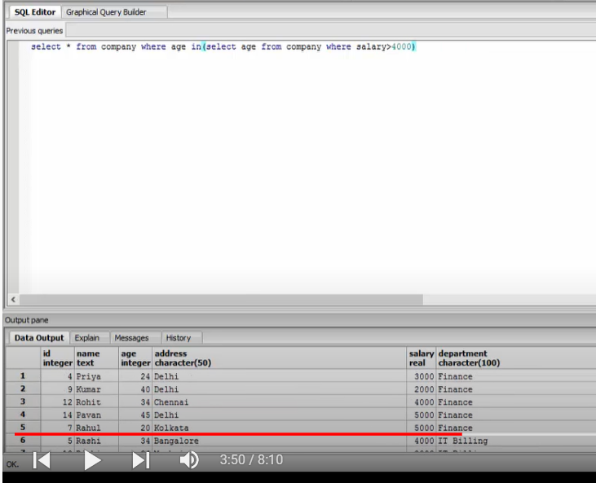

USED SUBQUERIES IN THE ABOVE.

WE CAN ALSO SEE PEOPLE WITH < 4000 SALARY. this is due to the subquery , and the values of the ages that are being returned , for example in the first query there maybe a person aged 25 who has a salary above 4000 , hence 25 is included in the list , while in the outer query all people are selected whose age is 25. Hence there is no restriction of the salary in the outer query.

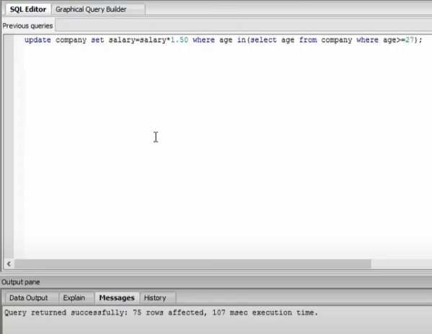

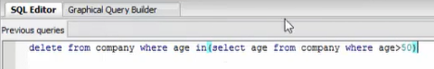

SOME POSTGRE SQL IMP COMMANDS REVISED—

SELECT * FROM employees;

SELECT * FROM employees WHERE department = ‘Sports’;

##below finding total salary for each department.

SELECT SUM(salary) as total_salary, department FROM employees GROUP BY department;

##below finding departments having > 50 employees.

SELECT count(*) as total_employee,department FROM employees GROUP BY department HAVING COUNT(*) > 50;

# Find total salary by each department and sort **descending by**total salary column.

SELECT SUM(salary) as total_salary,department FROM employees  
GROUP BY department  
**ORDER BY** total_salary desc

# Write a query that finds the first 5 employees with their first_name, department and salary and sorted by their first_name.

SELECT first_name,department,salary from employees  
ORDER BY first_name  
**LIMIT 5**

Note: Default Order By clause sorts the result in ASCENDING order.

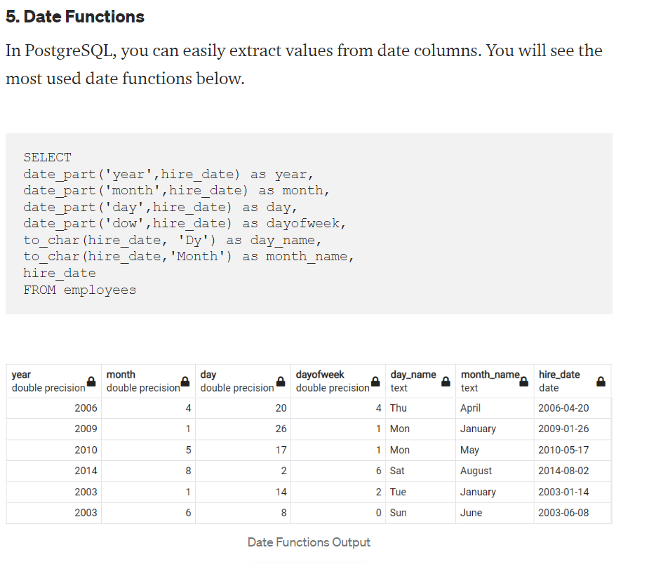

**Inner, Left or Right Joins**

**Inner Join** clause creates a new table (not physical) by combining rows that have matching values in two or more tables.

**Example:** Query all employee information and their divisions of the department.

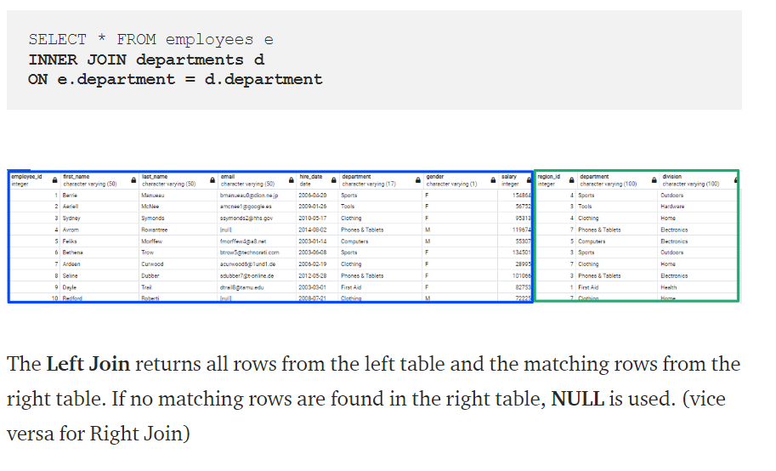

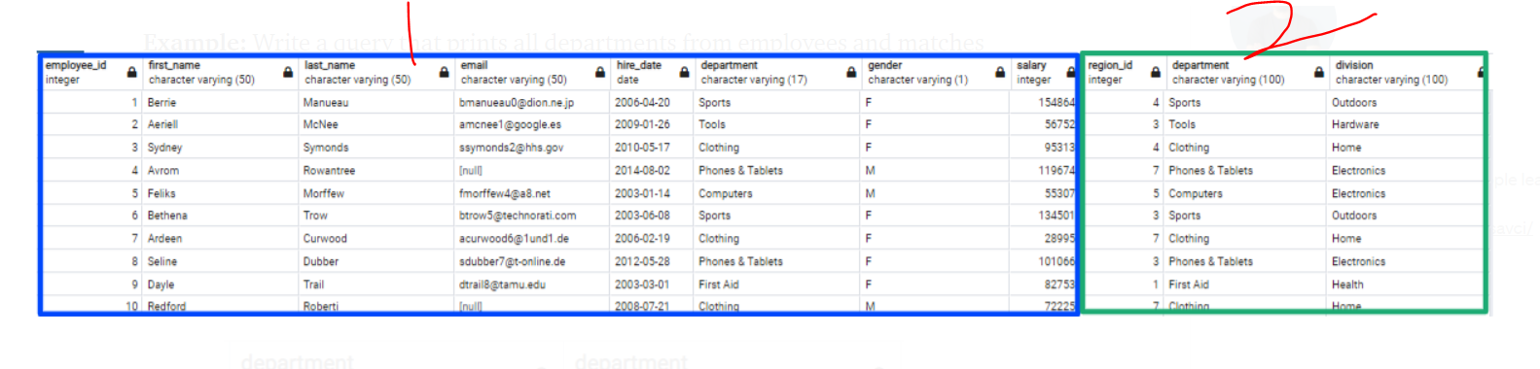

1 IS EMPLOYEE TABLE AND 2 IS DEPARTMENT TABLE.

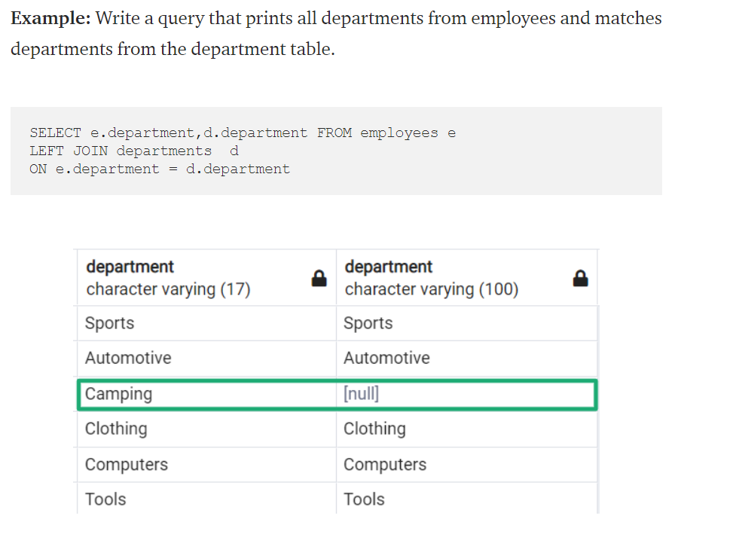

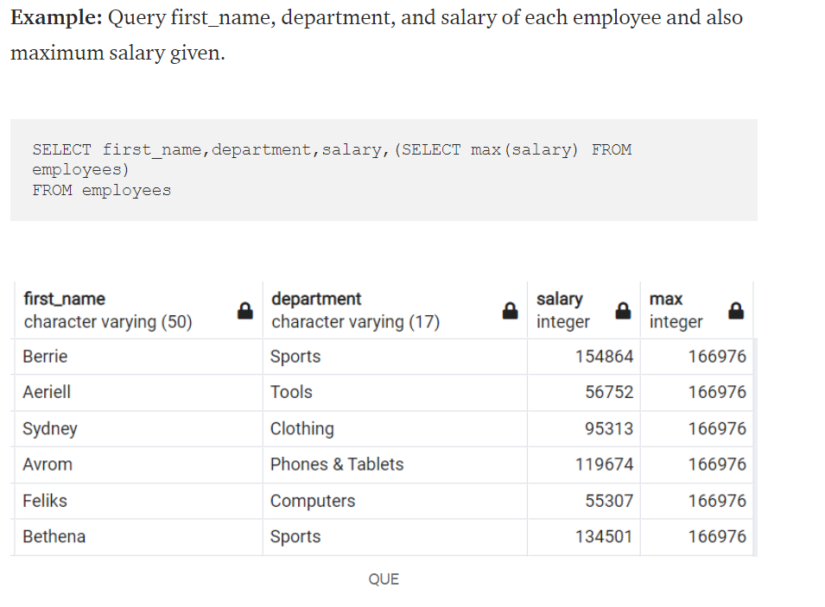

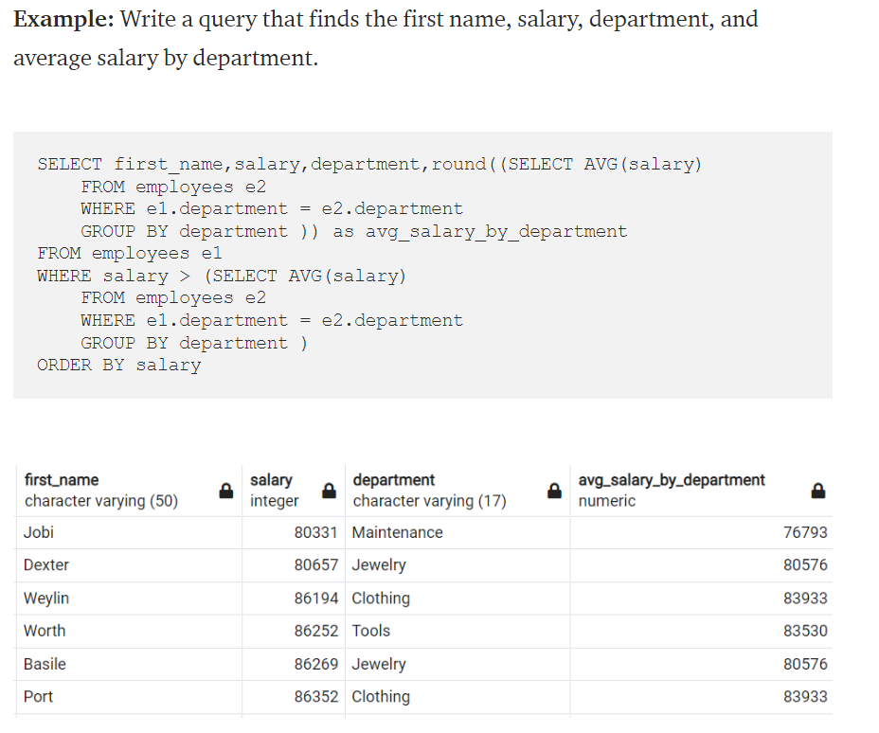

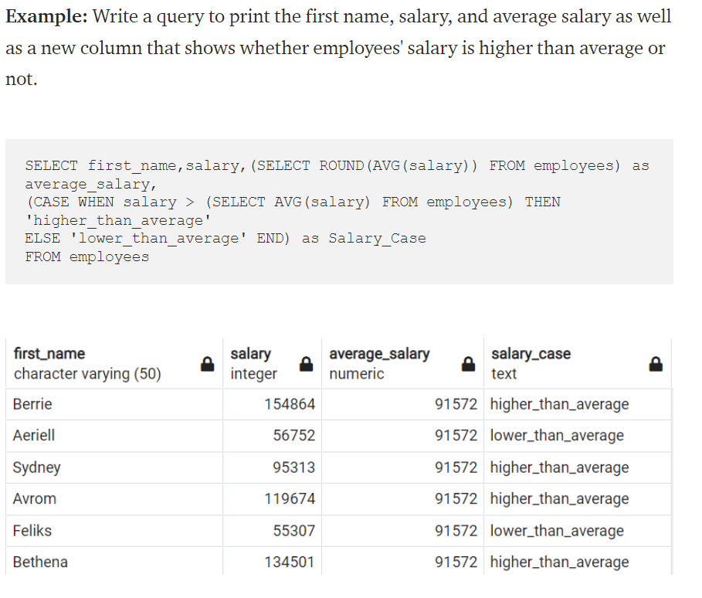

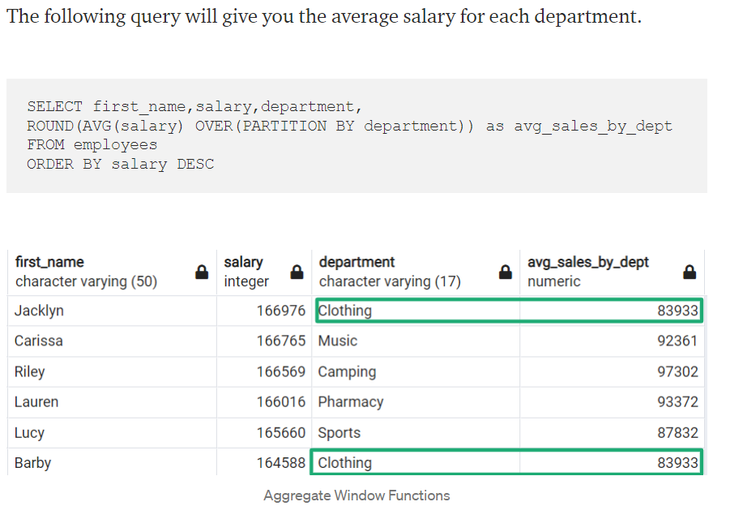

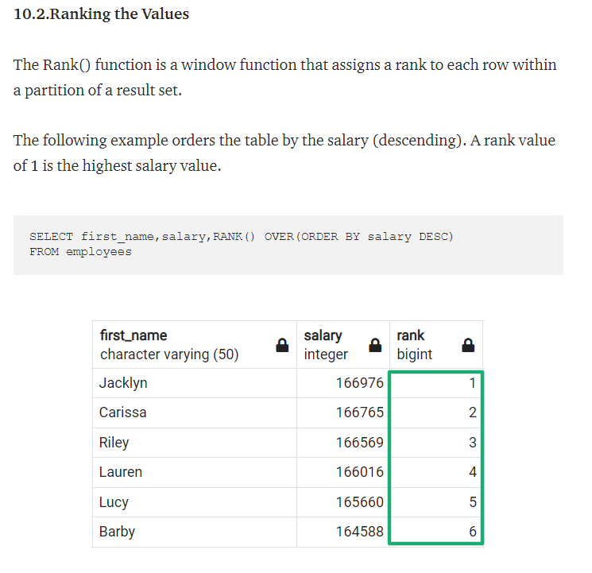

## ****Understanding the Basics****

The basics are more than just the basic commands, what matters most when answering difficult questions is the **order of operations!**Make sure you know this by heart. If you get in the habit of writing each line of a query in this order rather than from top to bottom I promise you’ll be a SQL wizard in no time!

1. **Order of Operations**

*FROM : the table your data is in  
WHERE: filters the table down to the contents where a certain condition is met  
GROUPBY: clusters the data into groups  
SELECT: actually pulls the data  
ORDER BY: orders the data  
LIMIT: puts a cap on the number of returns*

**Query Order**

*SELECT  
FROM  
WHERE  
GROUP BY  
ORDER BY  
LIMIT*

You might wonder why the code executes in one order but is written in another. Unfortunately, this is just the way it's designed.

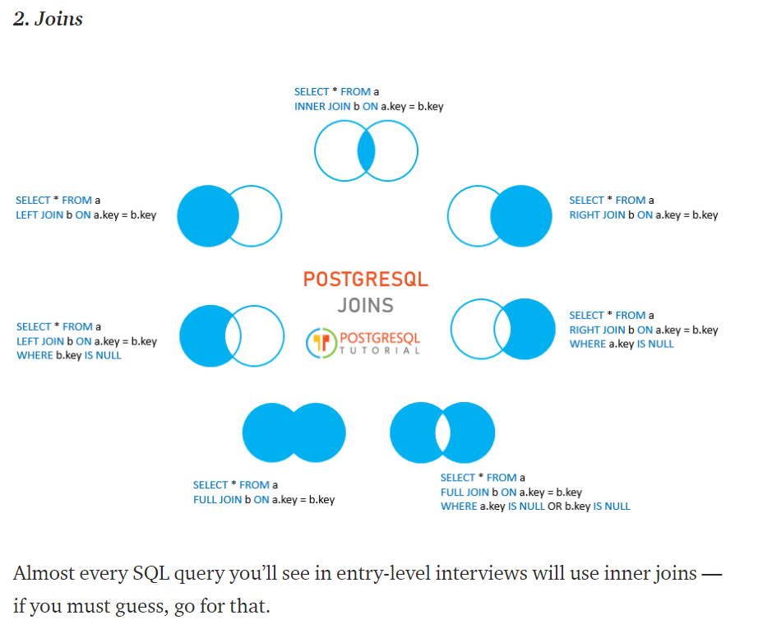

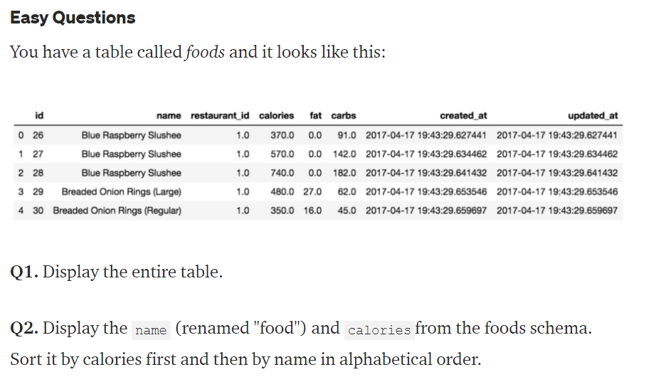

# Answers

**Q1.**

SELECT *  
FROM foods as f;

**Q2.**

SELECT f.name as “food”, f.fat  
FROM foods f  
ORDER BY f.calories DESC, f.name ASC;

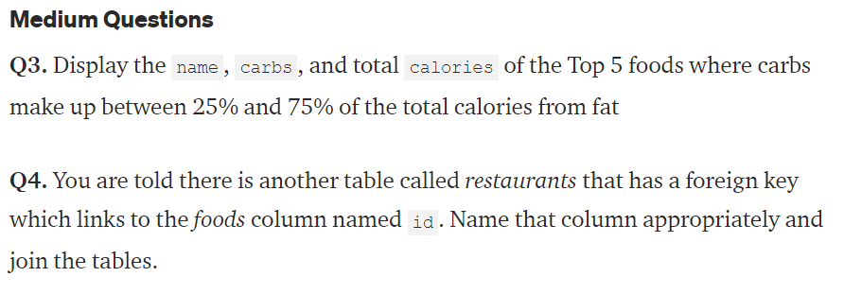

**Q3.**

SELECT f.name, f.carbs, f.calories  
FROM foods as f  
WHERE 100*f.carbs/(f.calories+0.001) BETWEEN 25 and 75  
ORDER BY 100*f.carbs/(f.calories+0.001) DESC  
LIMIT 5;

**Q4.**

SELECT f.id  
FROM foods as f  
INNER JOIN restaurants as r  
ON f.id=r.foods_id;

This question tests your knowledge of appropriate naming schemas, note that foreign keys should reference the table they are a key for!

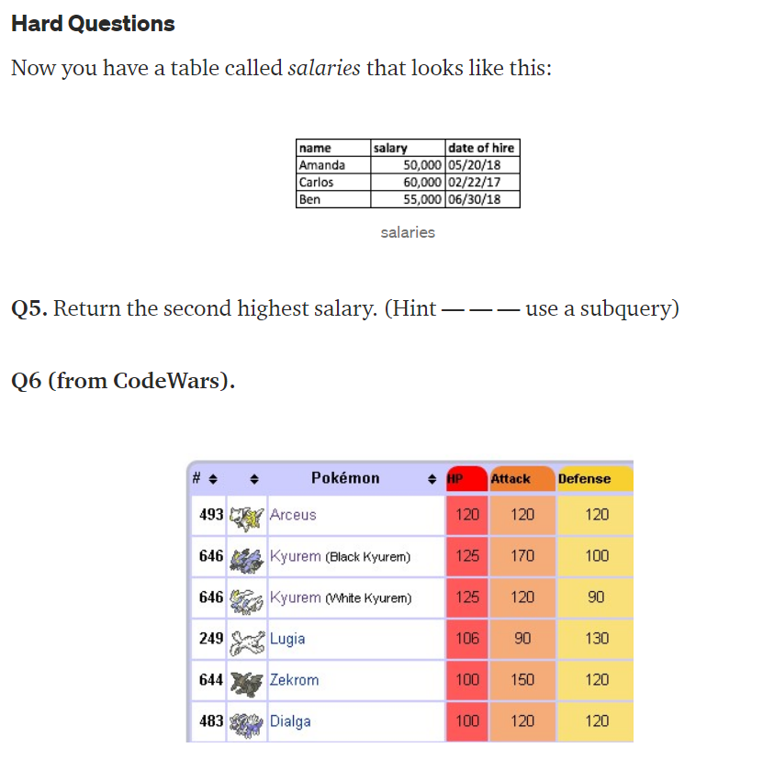

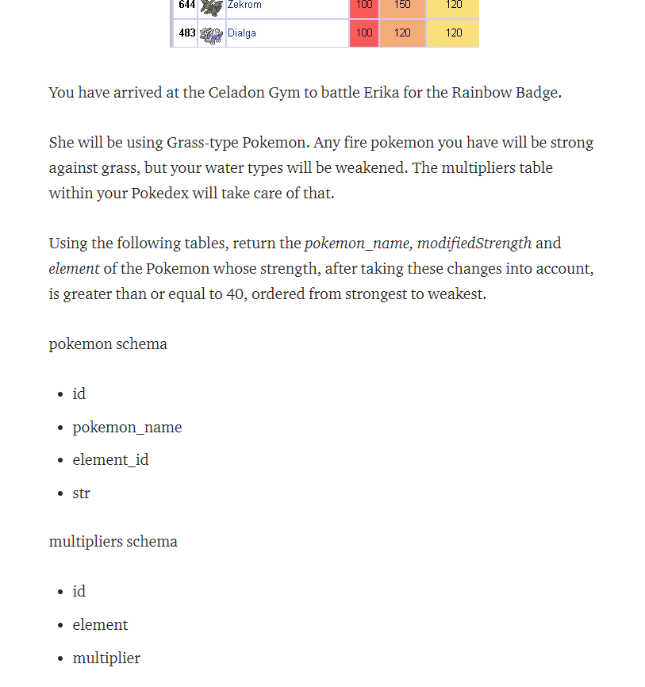

**Q5.**

SELECT Max(salary)  
FROM salaries  
WHERE salary NOT IN (SELECT Max(salary) FROM salaries);

**Q6.**

SELECT pkmn.pokemon_name,  
pkmn.str*mult.multiplier as modifiedStrength,  
mult.element  
FROM pokemon as pkmn  
INNER JOIN multipliers as mult ON pkm.element_id = mult.id  
WHERE pkm.str*mult.multipler ≥ 40  
ORDER BY modifiedStrength DESC